**Chapter 1**

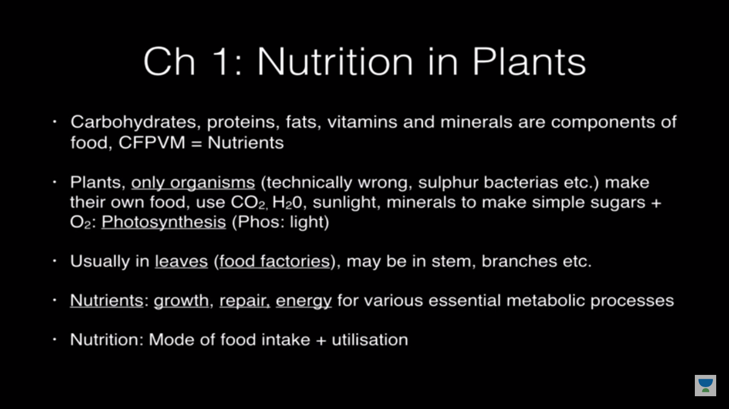

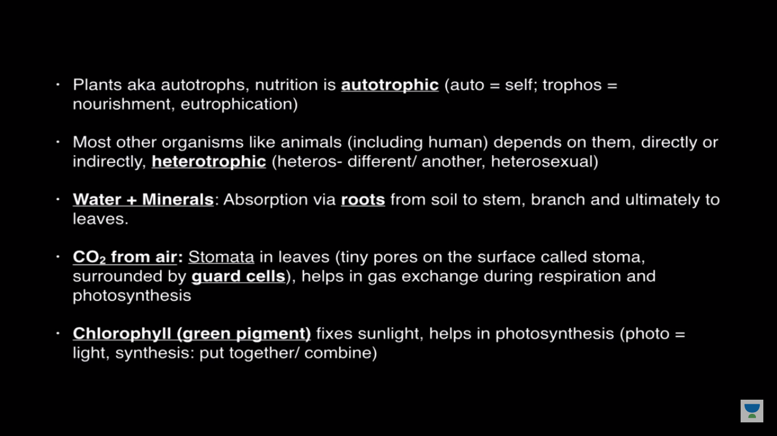

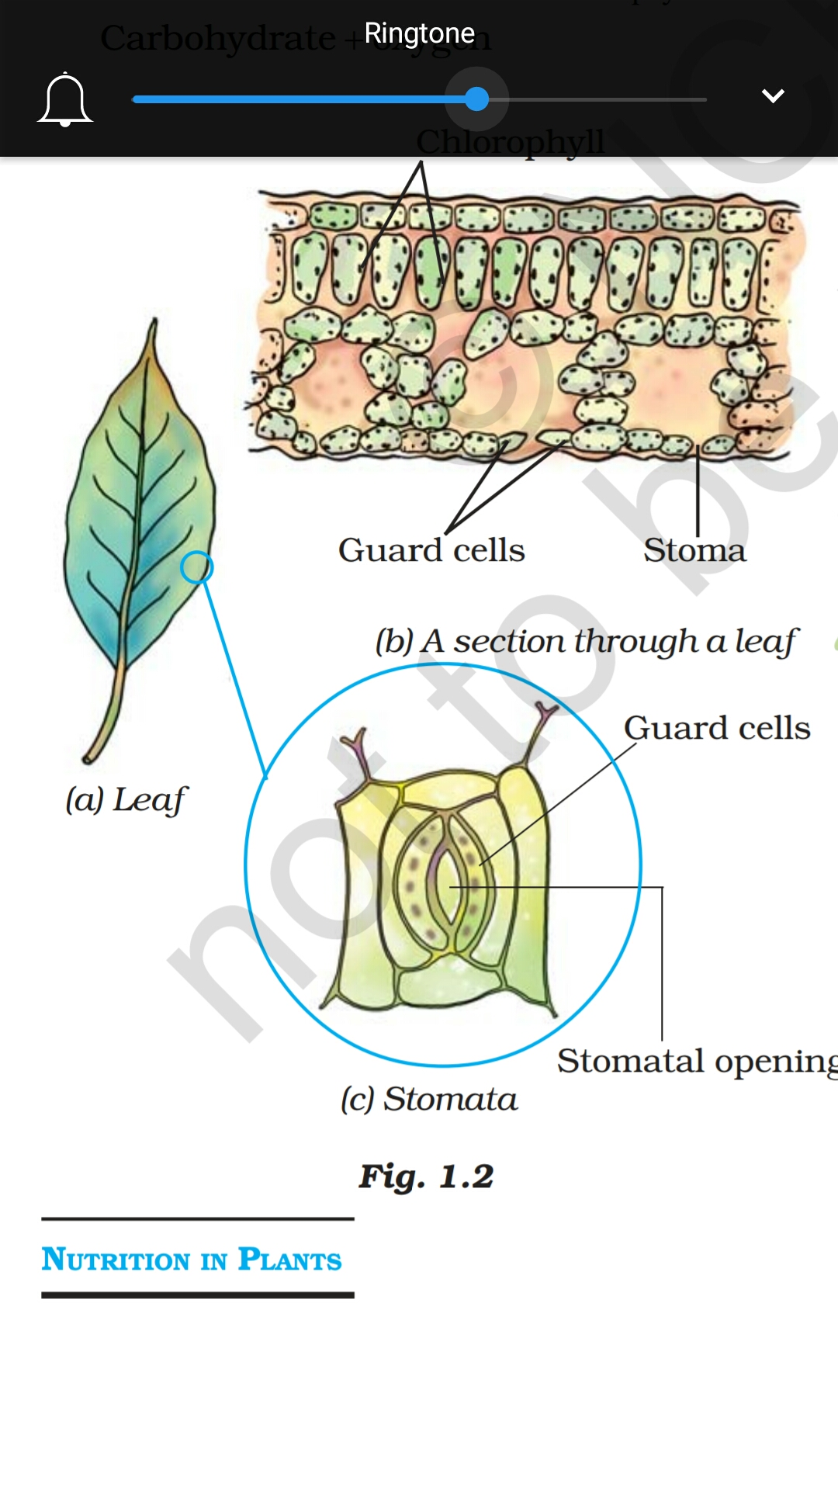

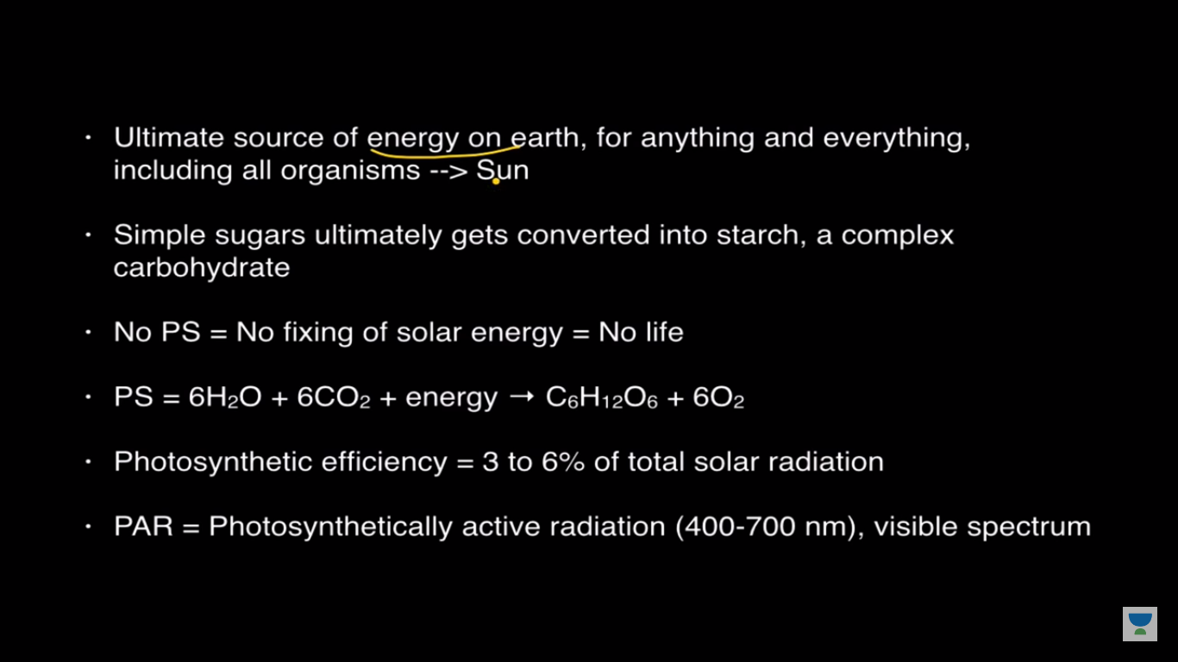

mono sacrite- Glucose,galactose,fructose

dia scarite-maltose

table sugar->sucrose==glucose+fructose

Lctose=glocose+galactose

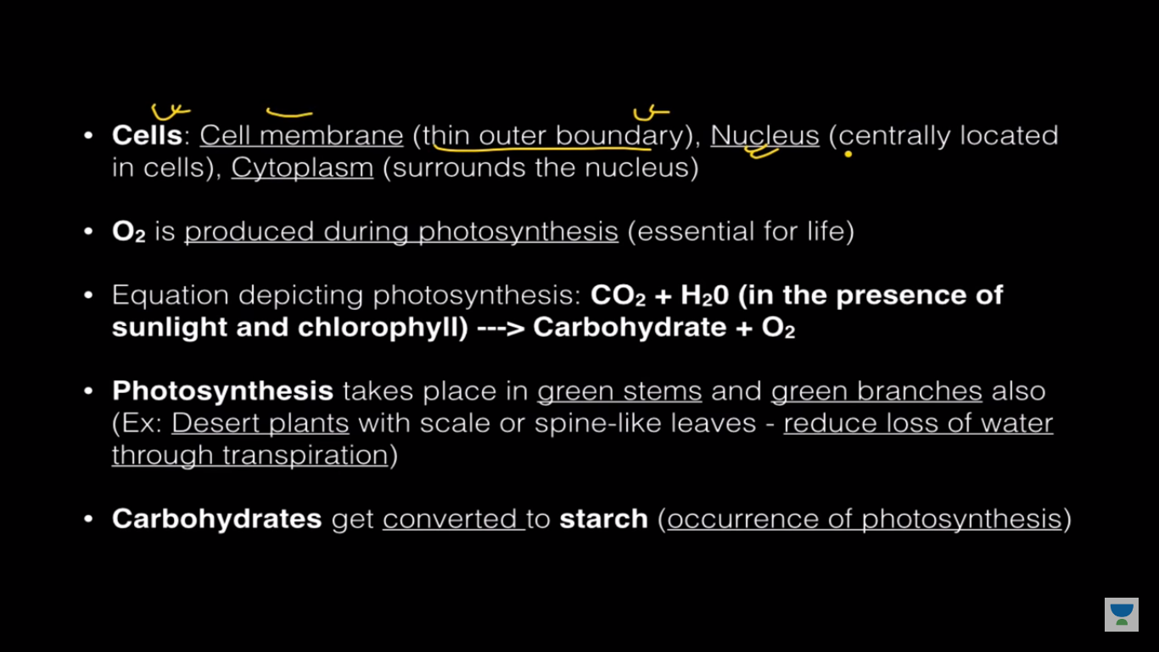

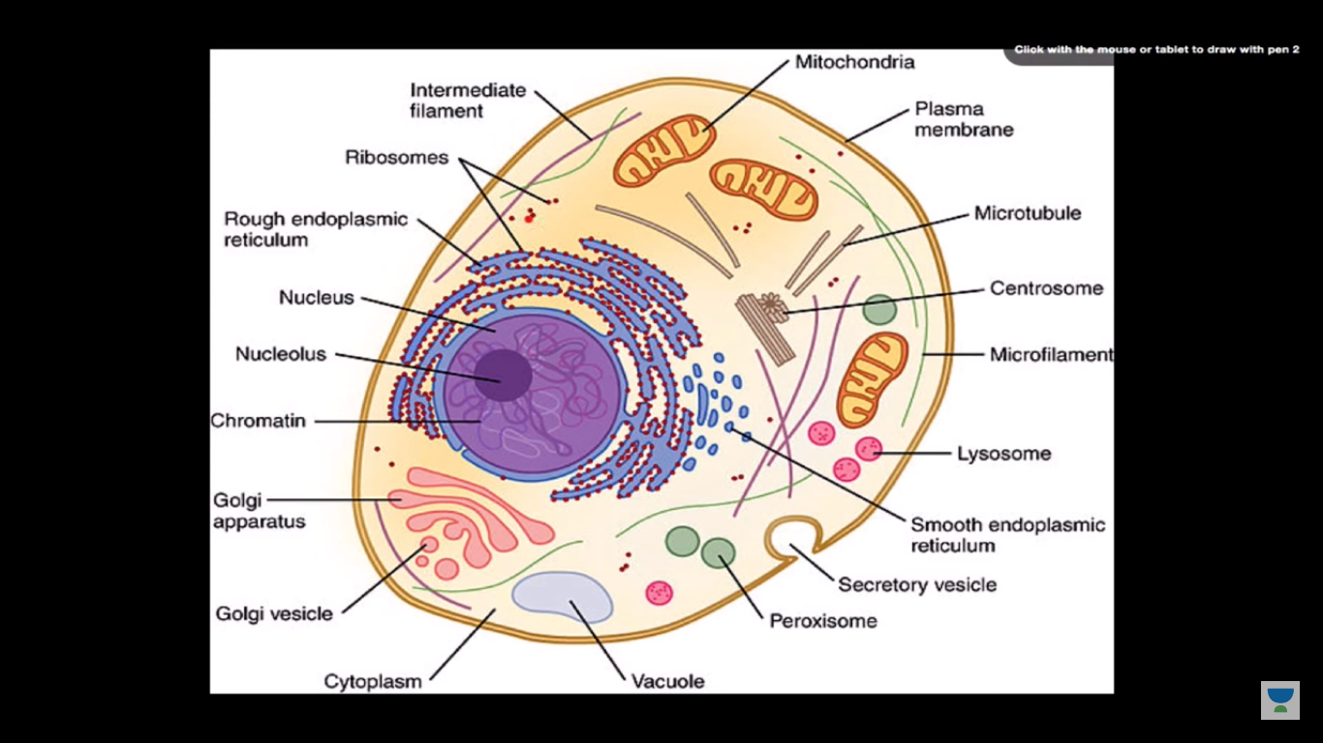

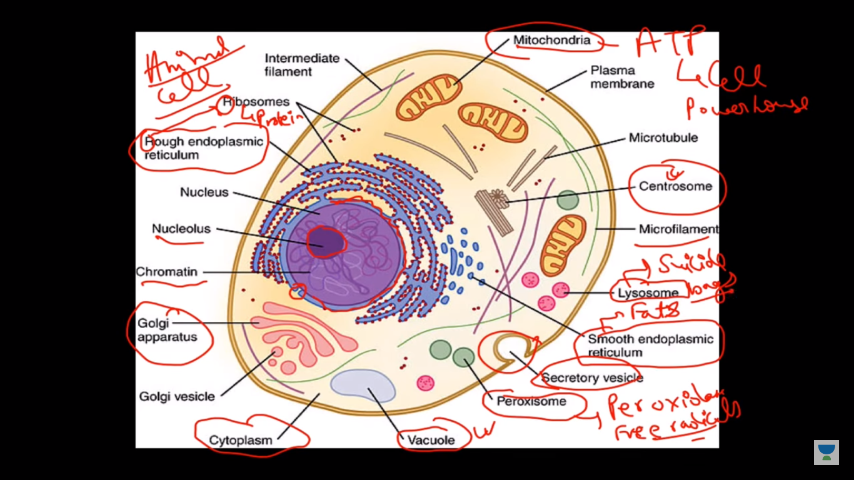

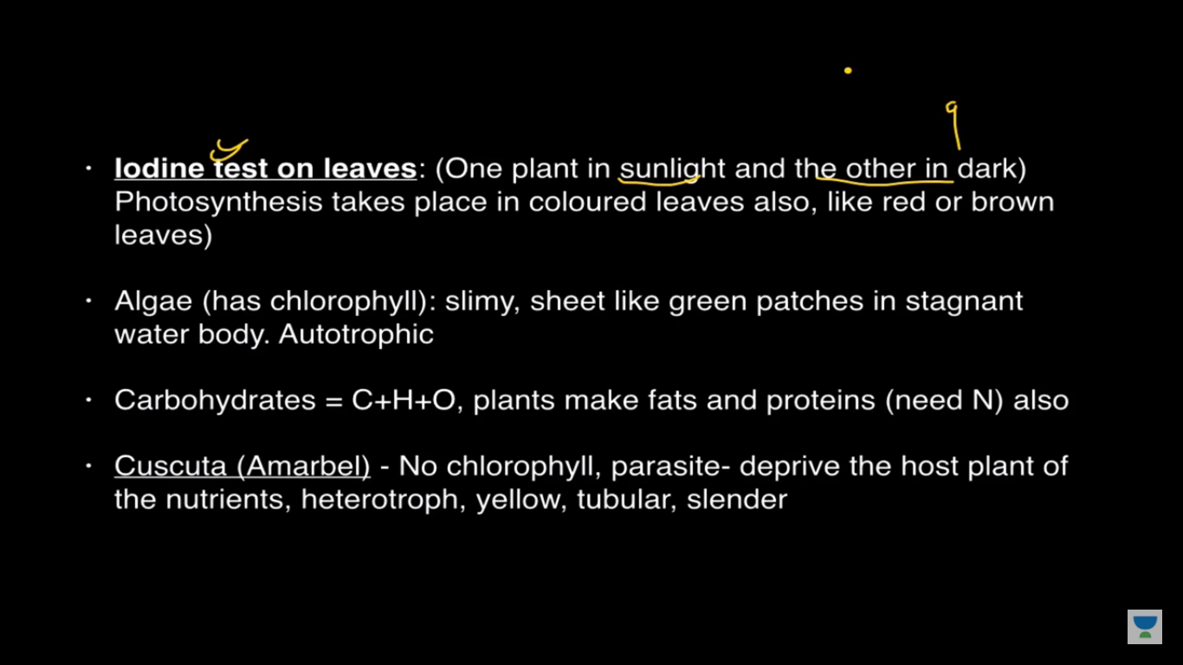

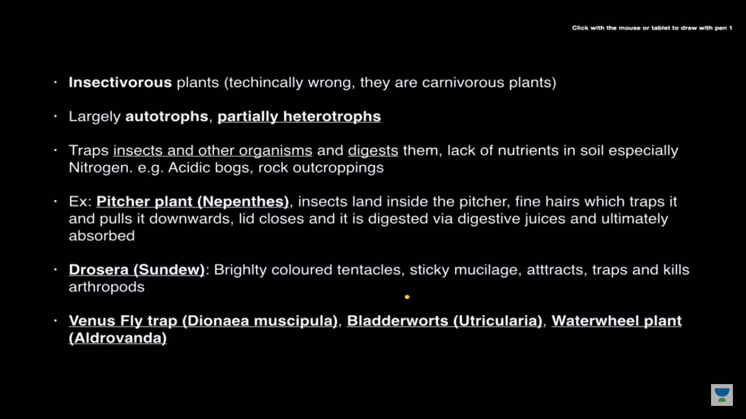

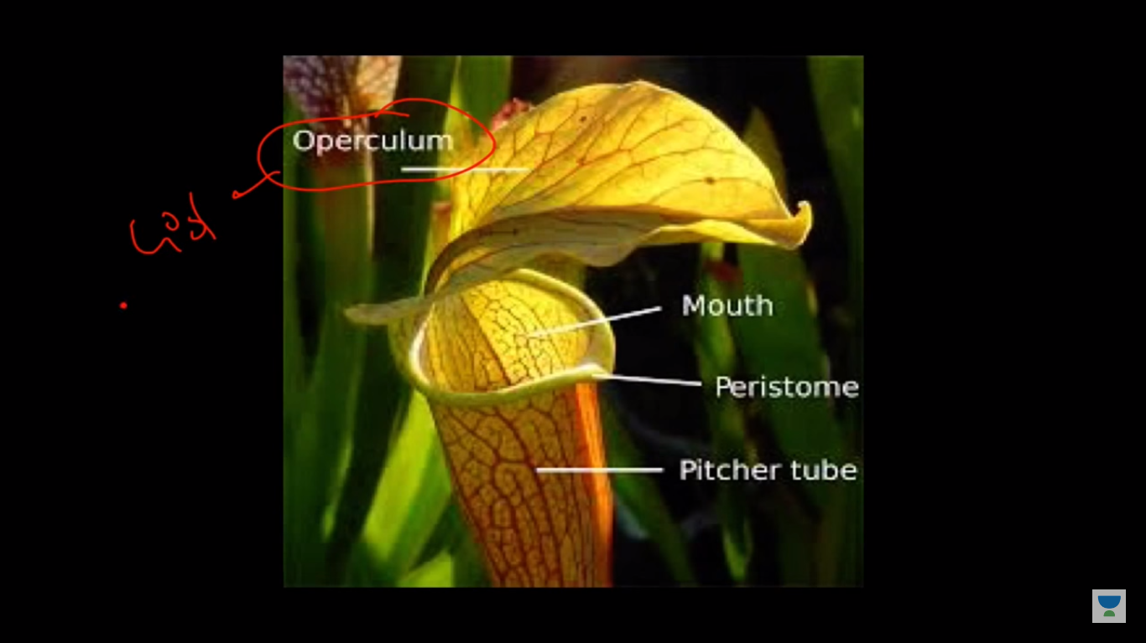

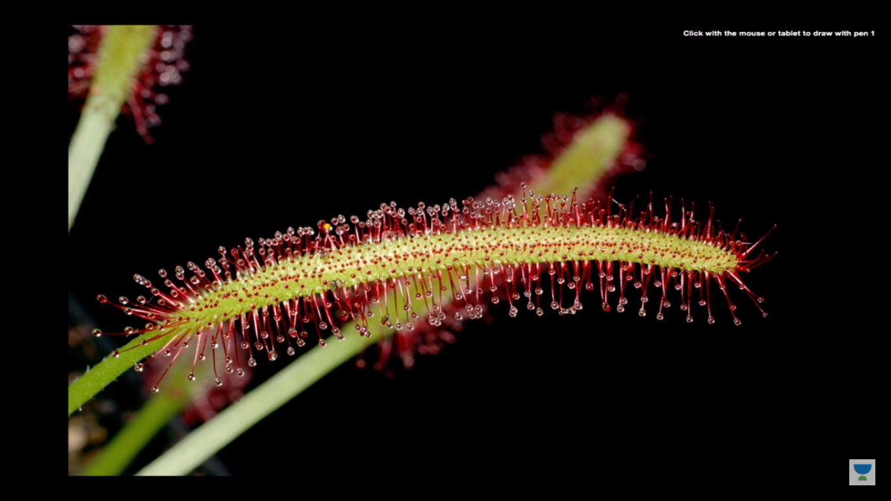

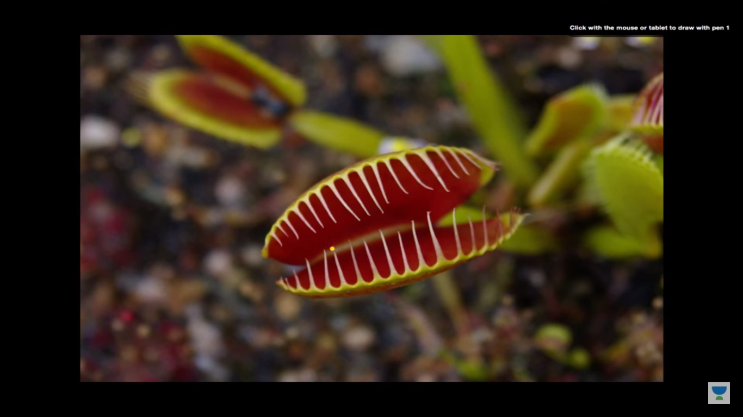

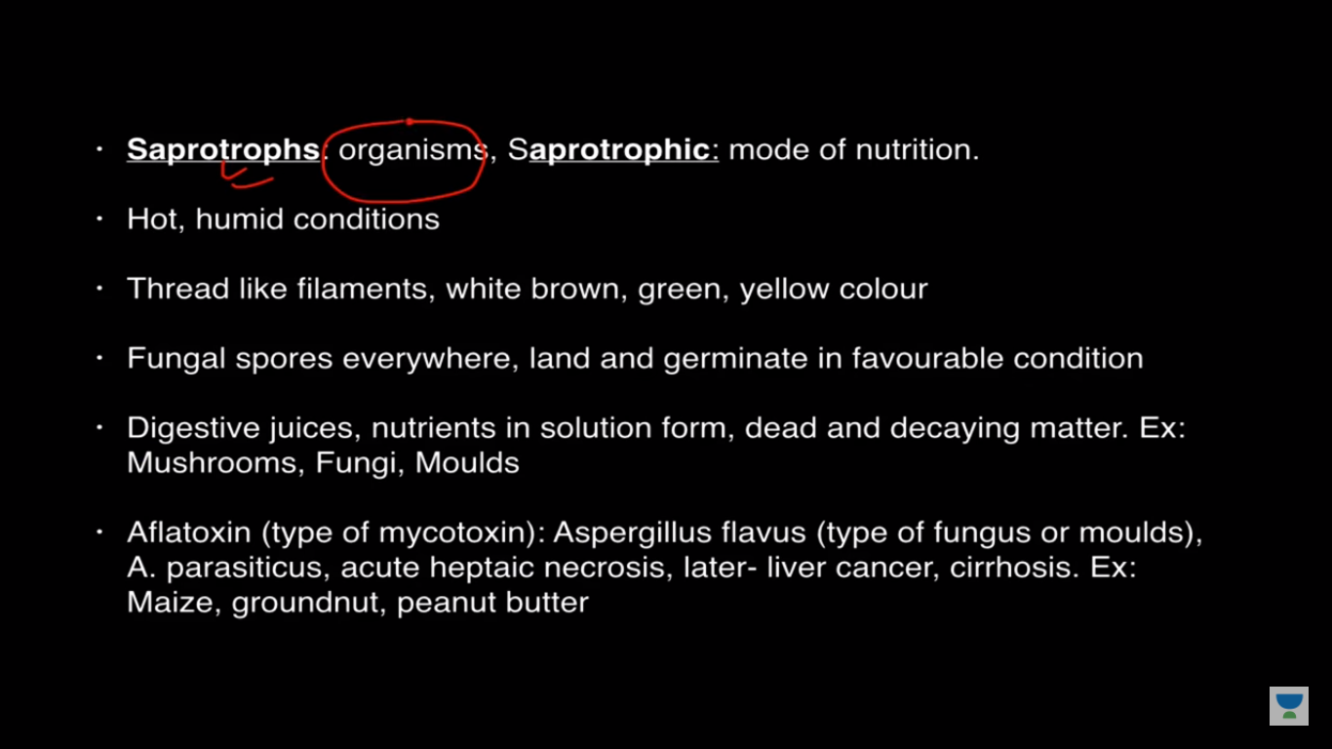

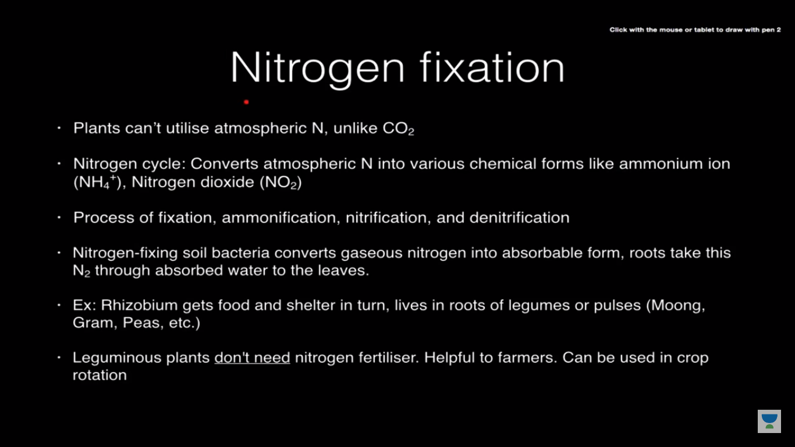

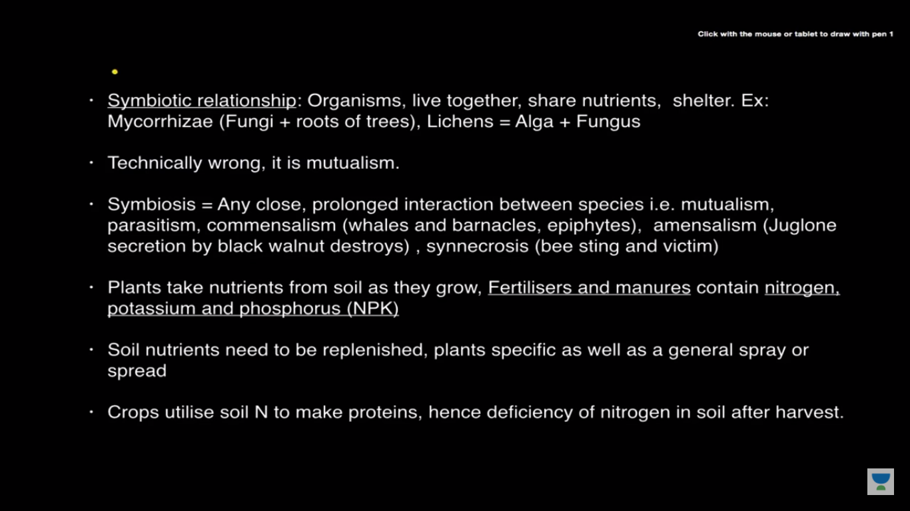

**Chapter 2**

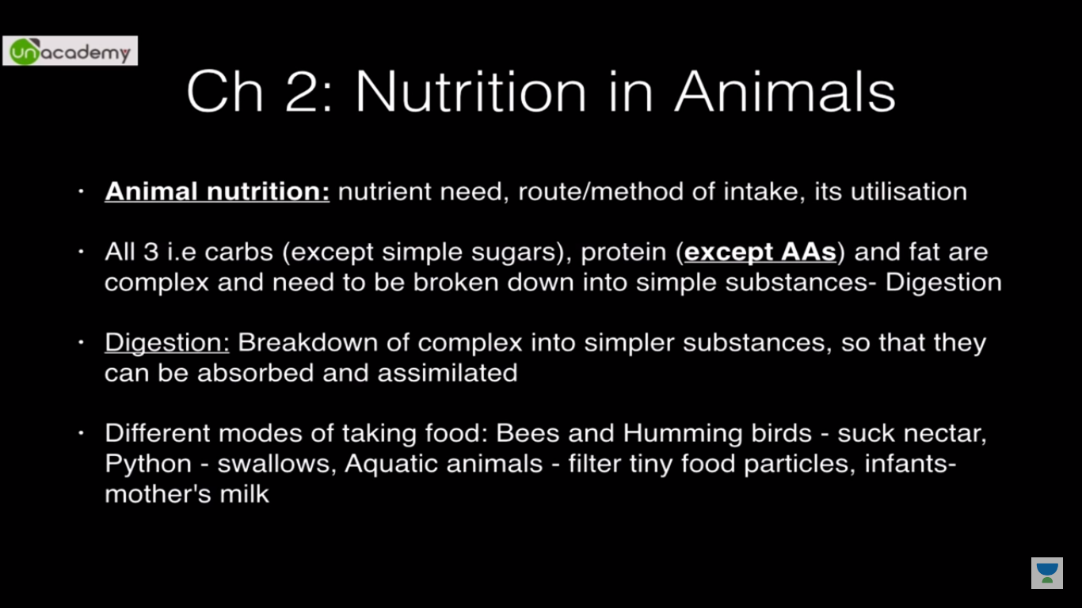

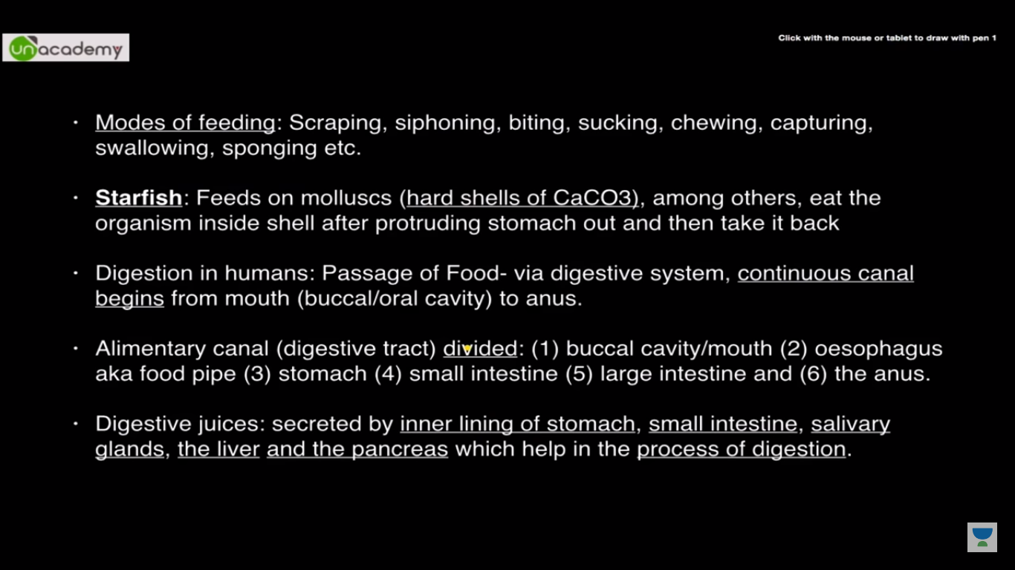

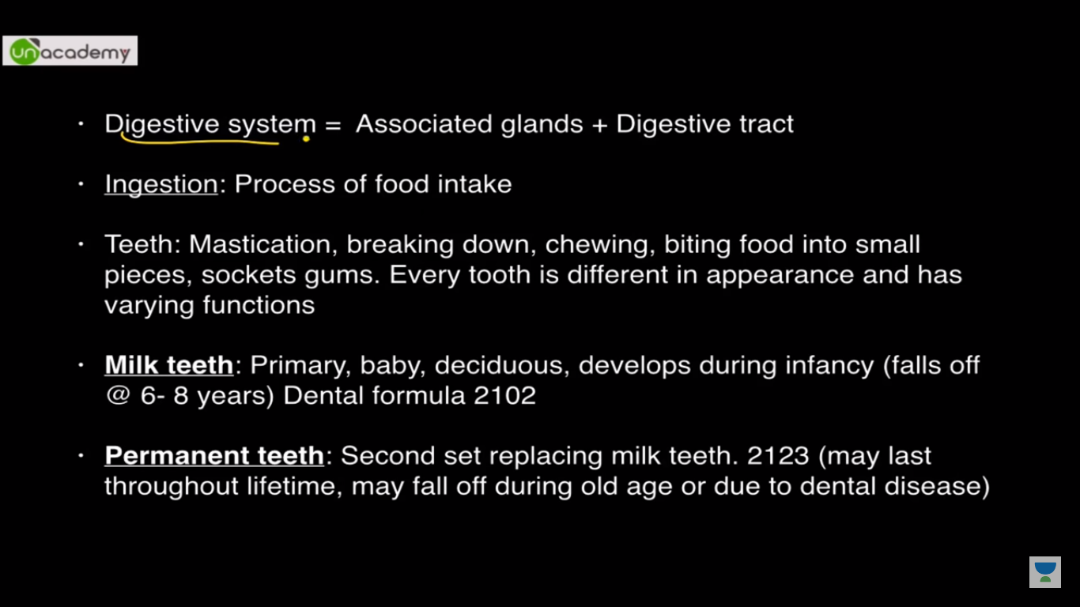

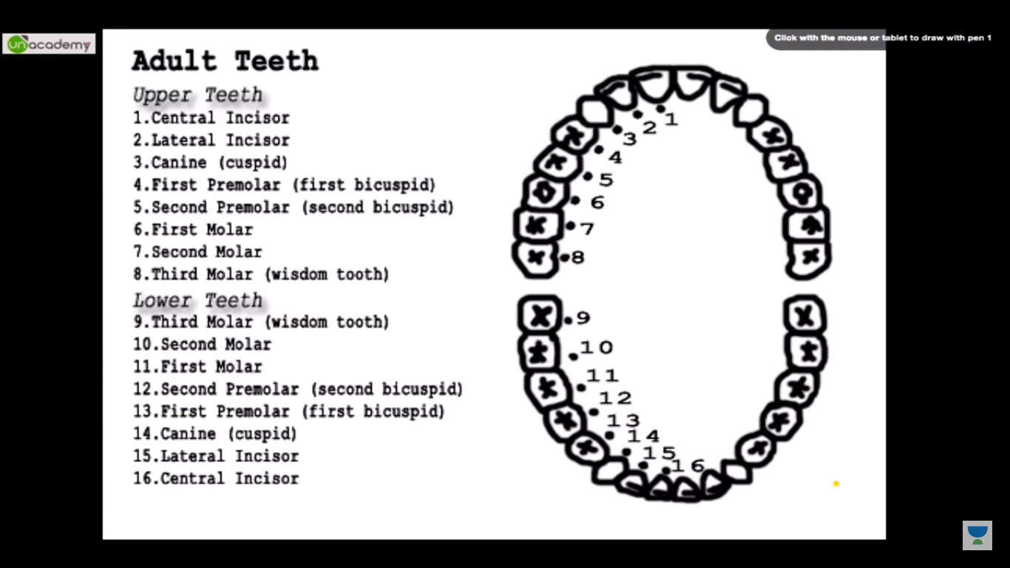

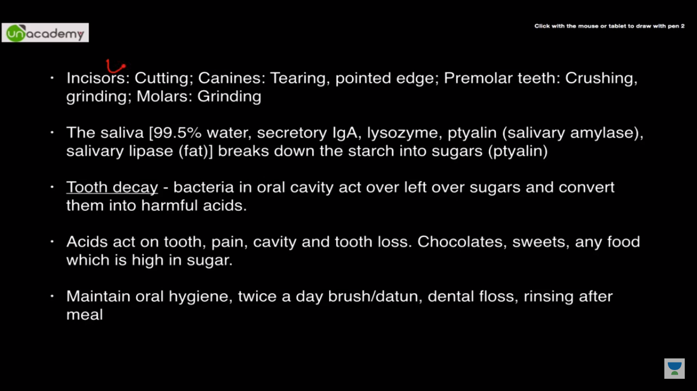

Secretory IgA-->GAMDE--Prevention of infection

Enamel is the hardest substance in animal kingdom

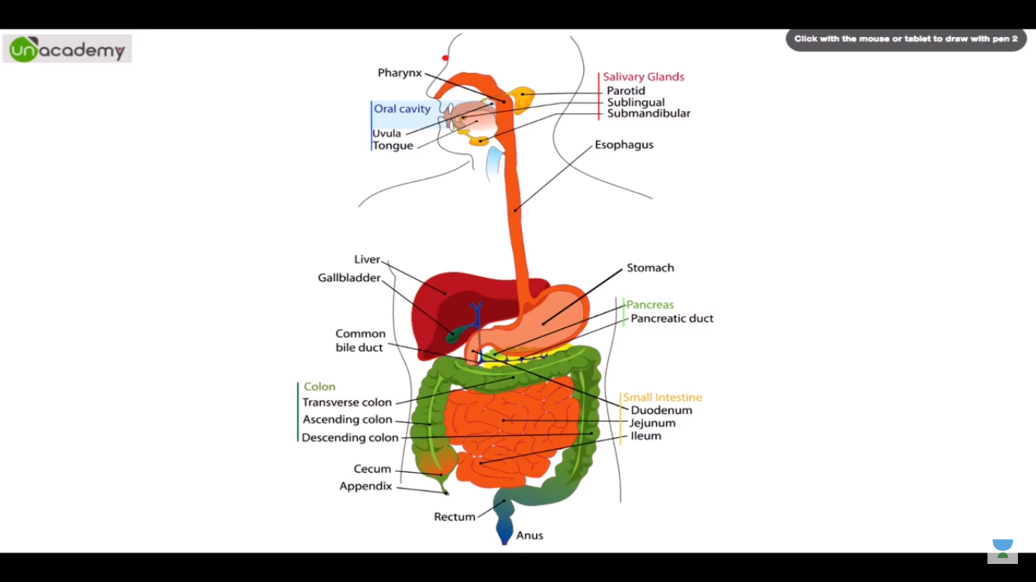

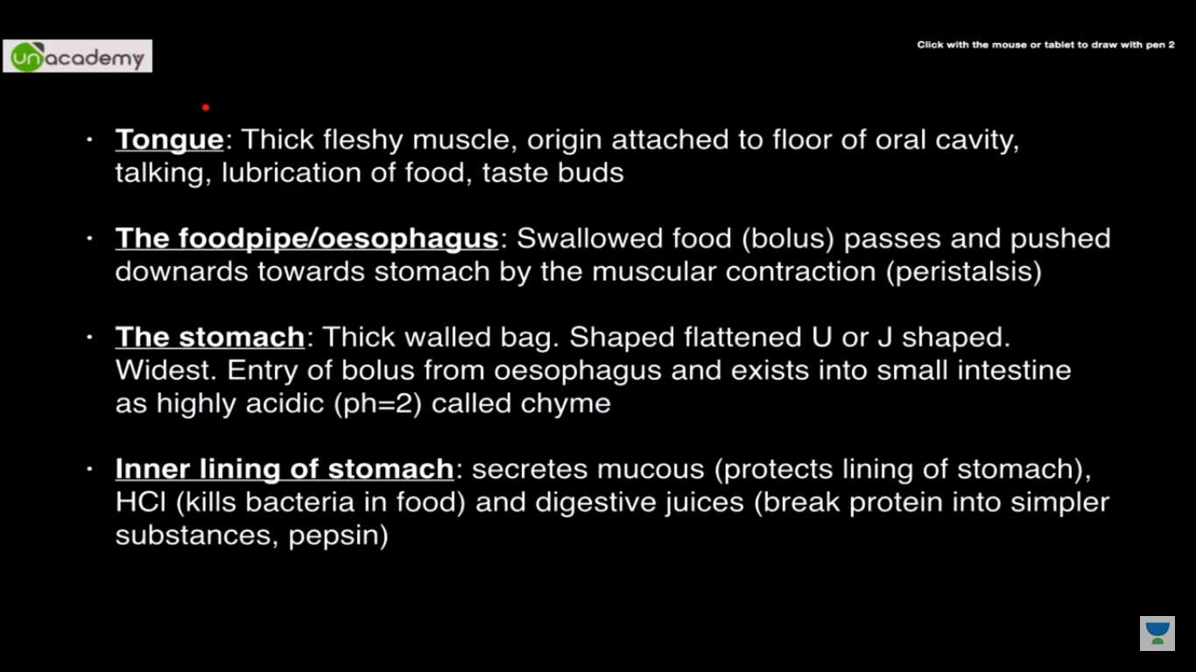

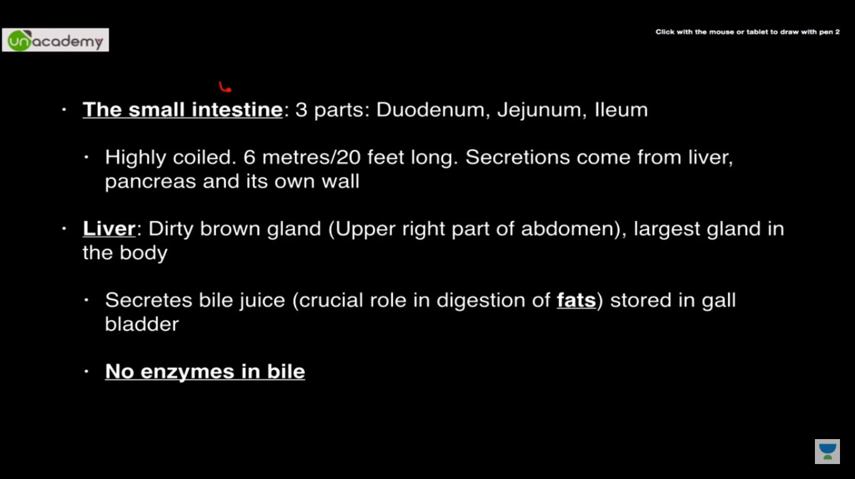

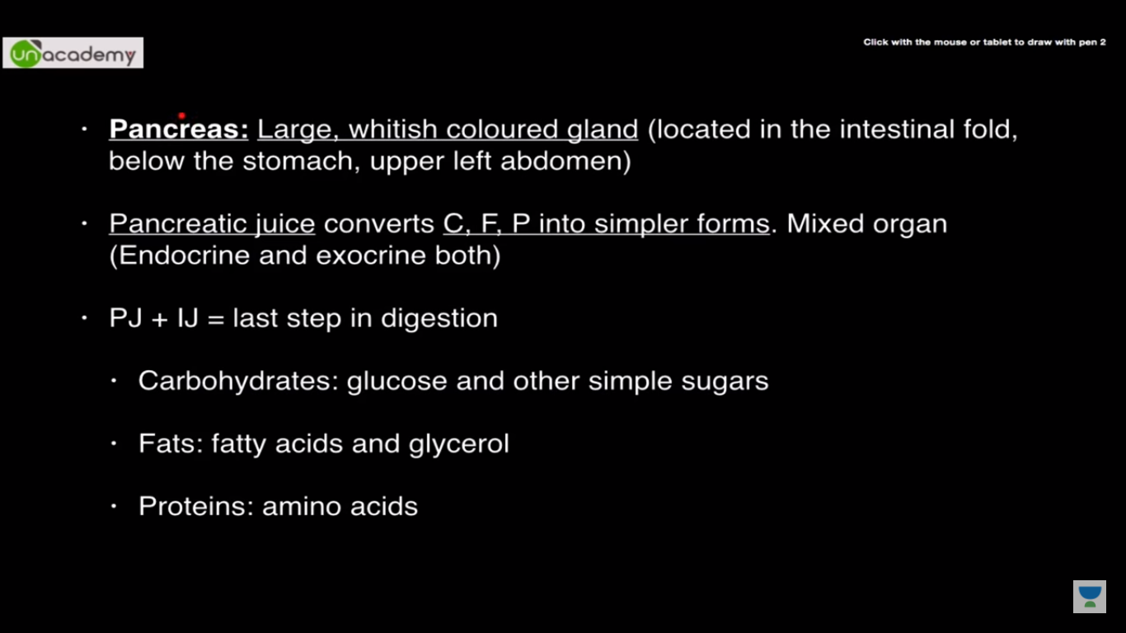

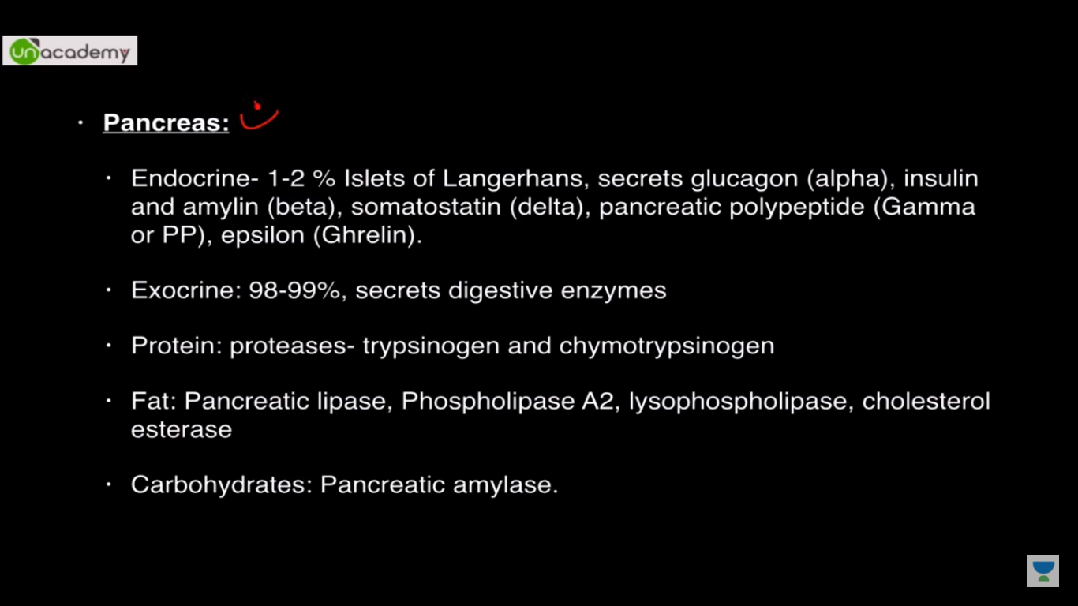

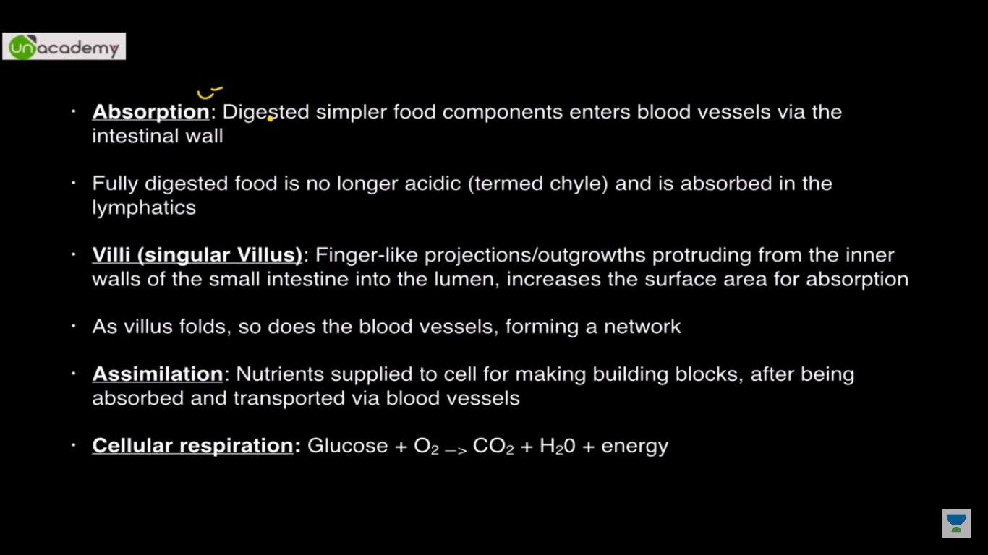

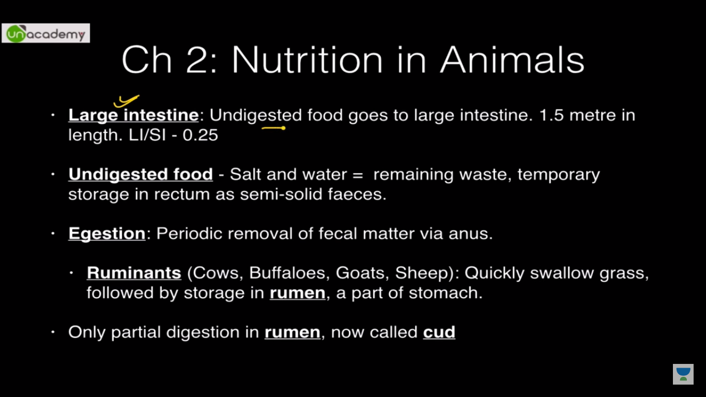

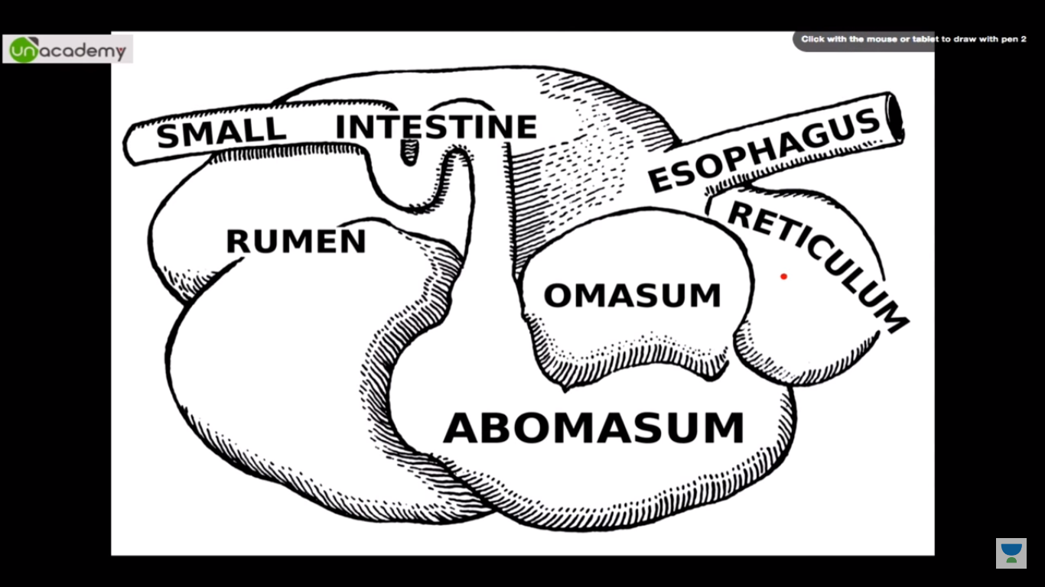

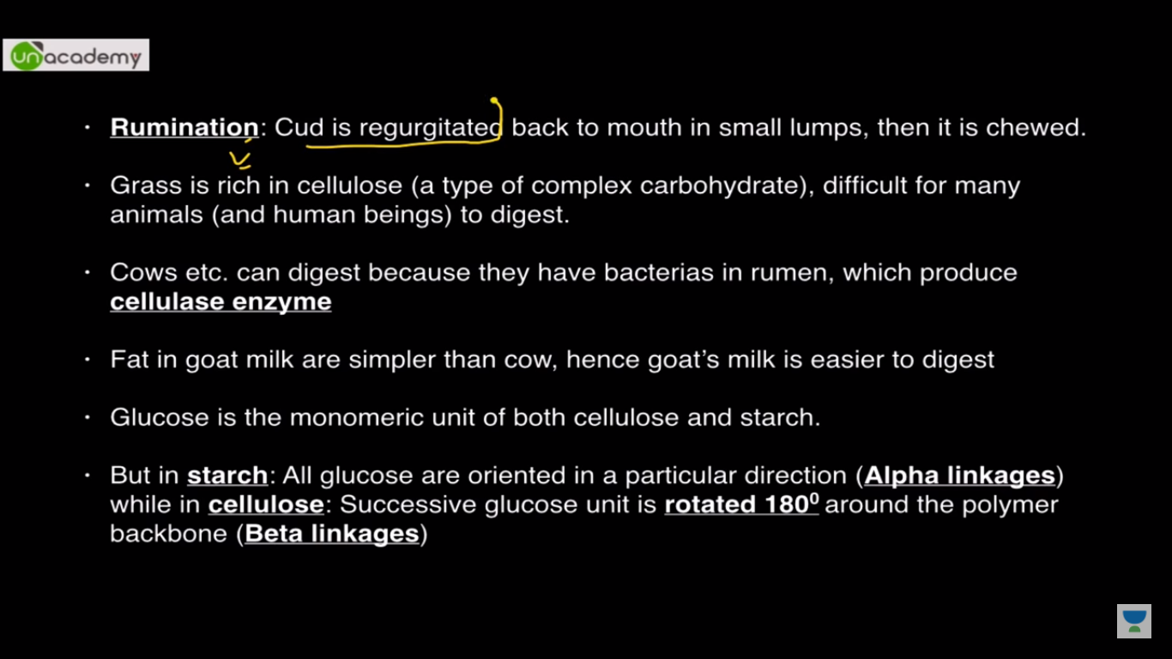

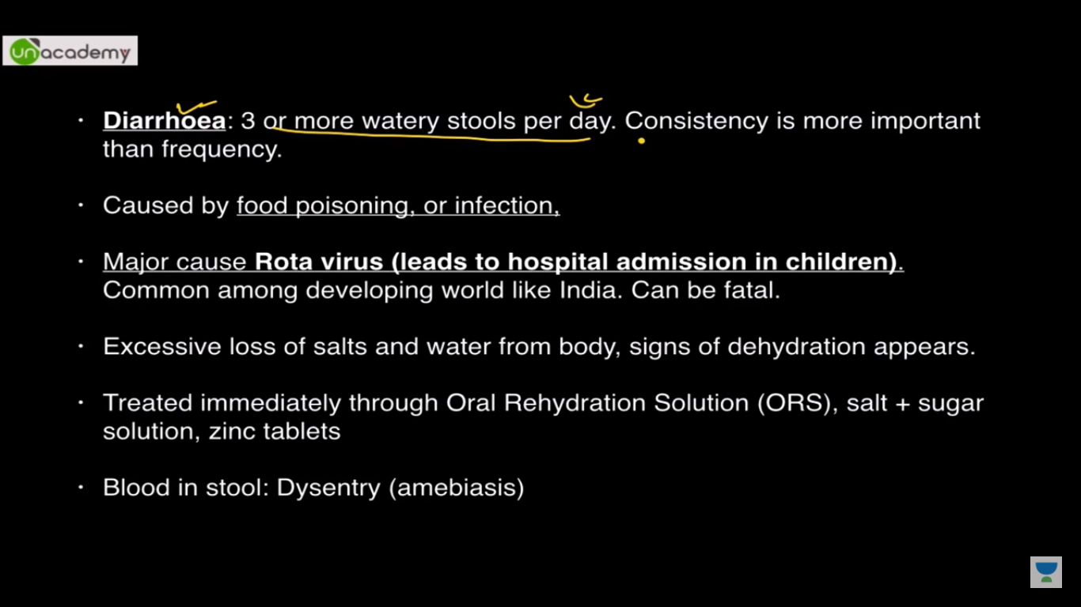

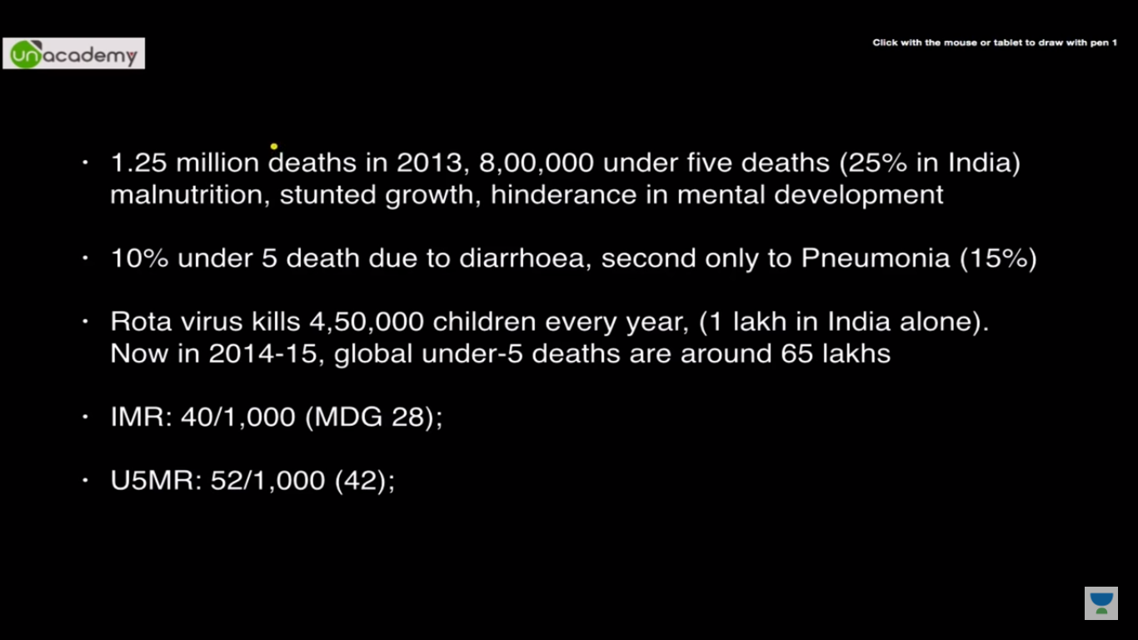

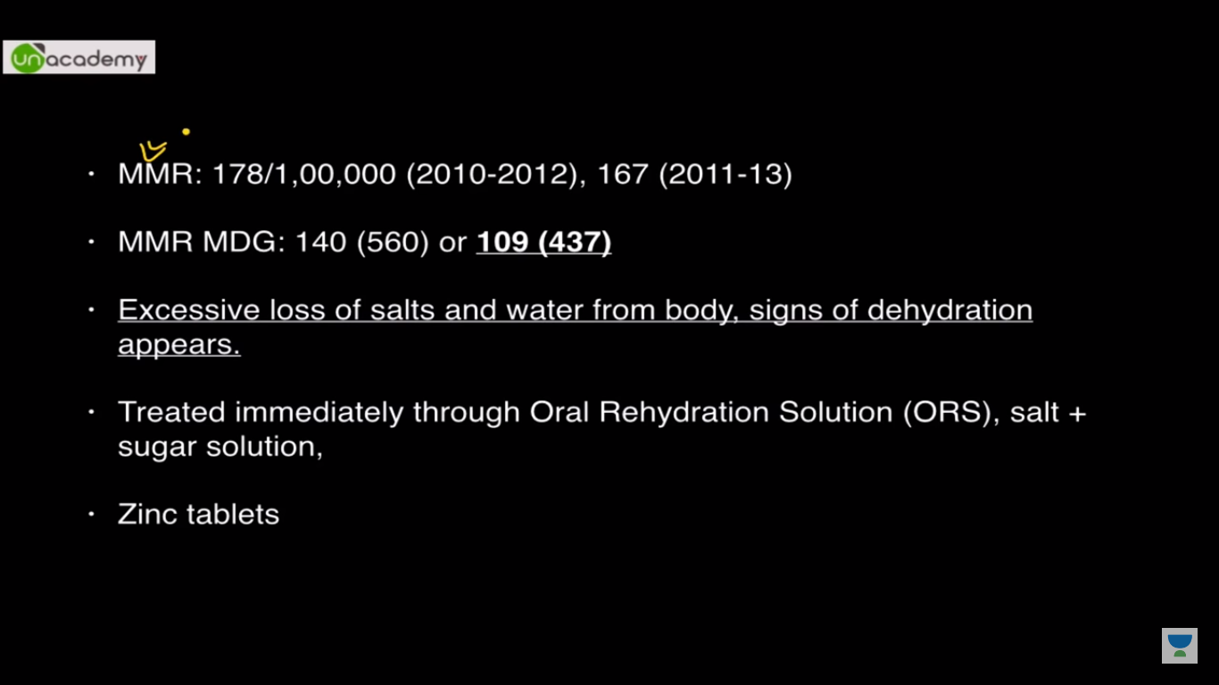

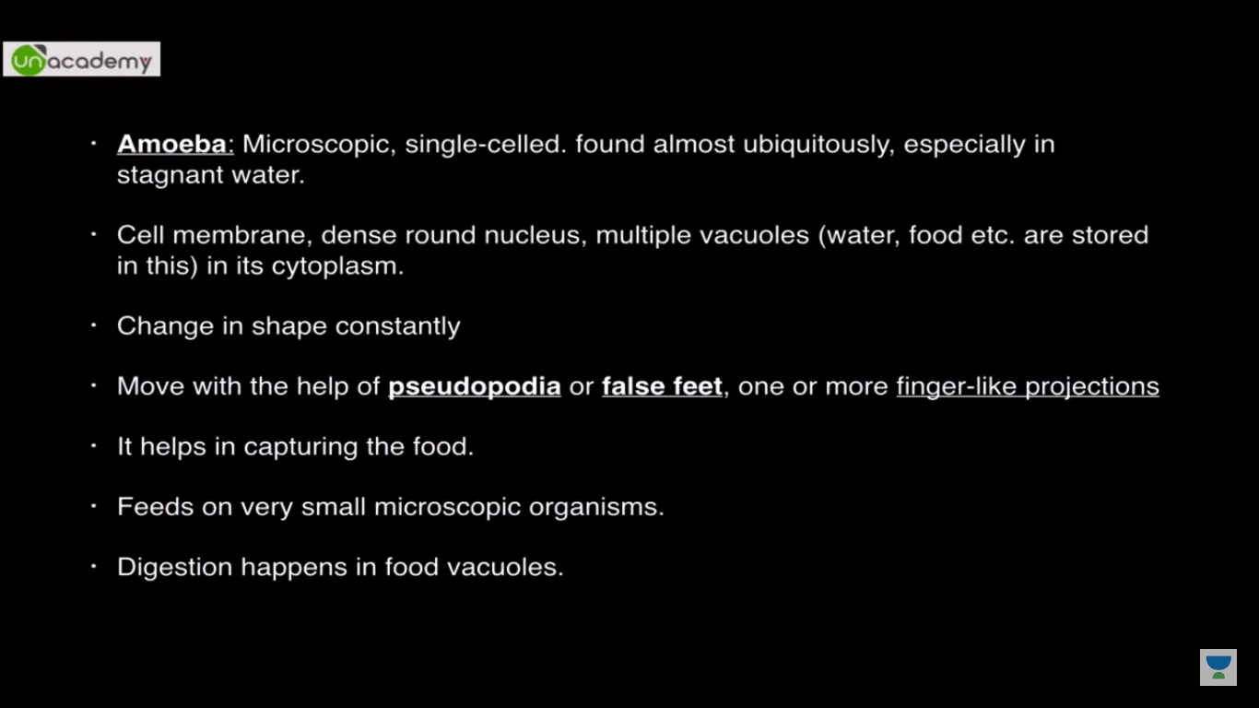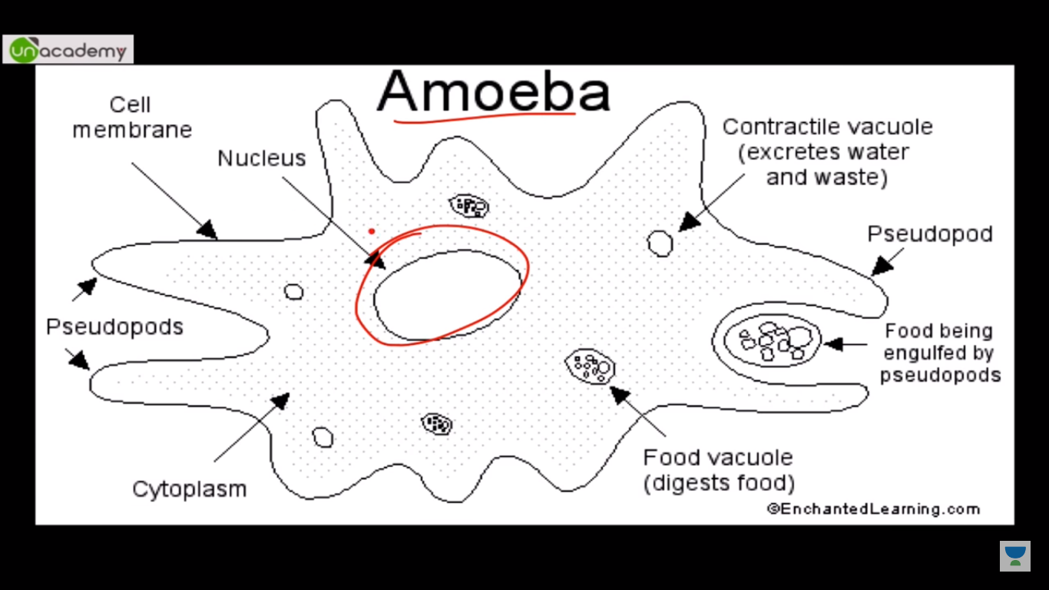

**Chapter3:**

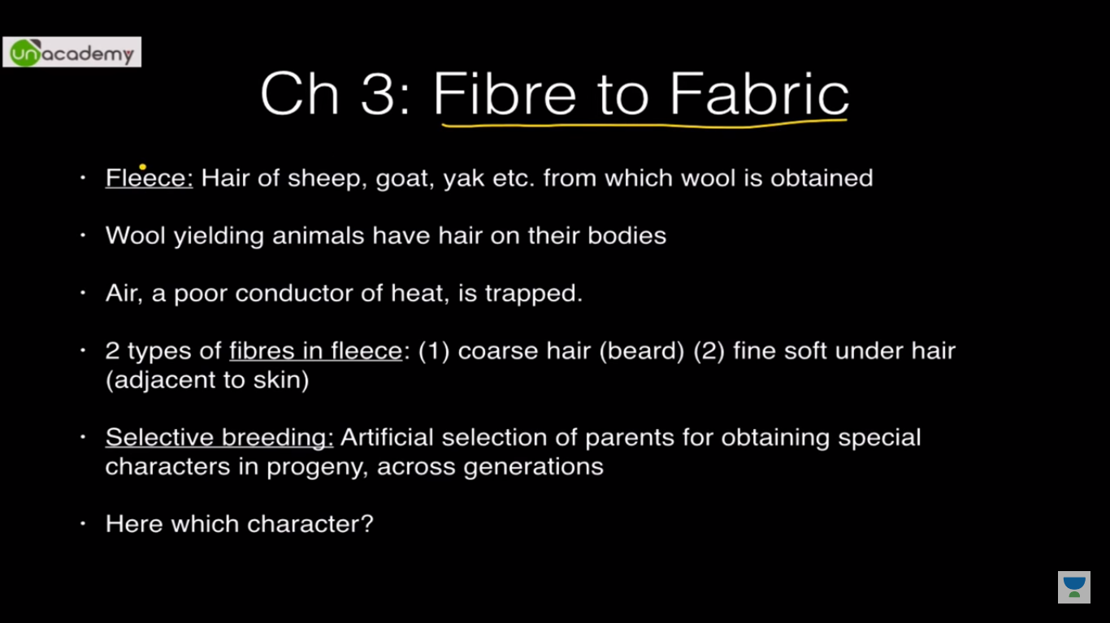

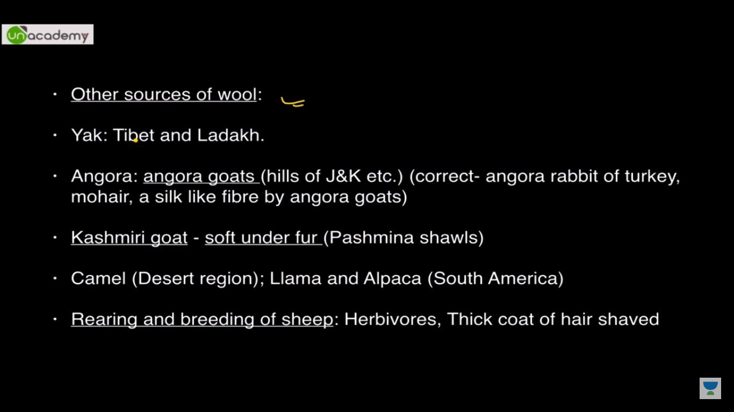

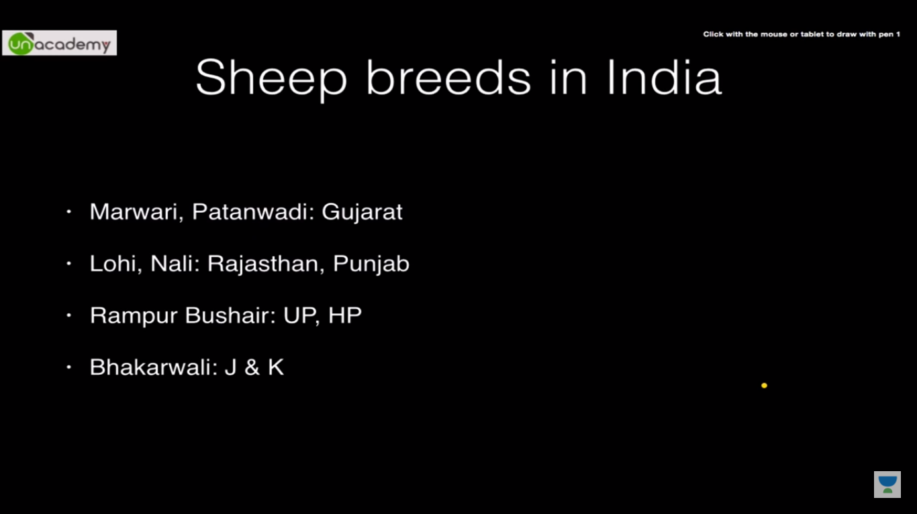

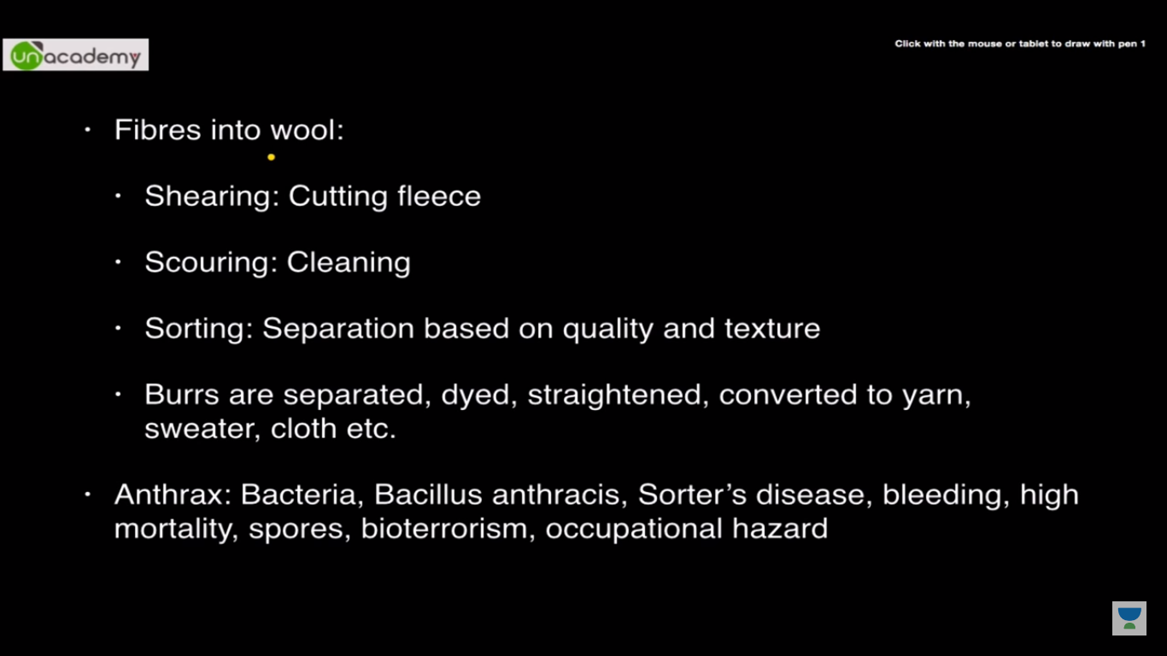

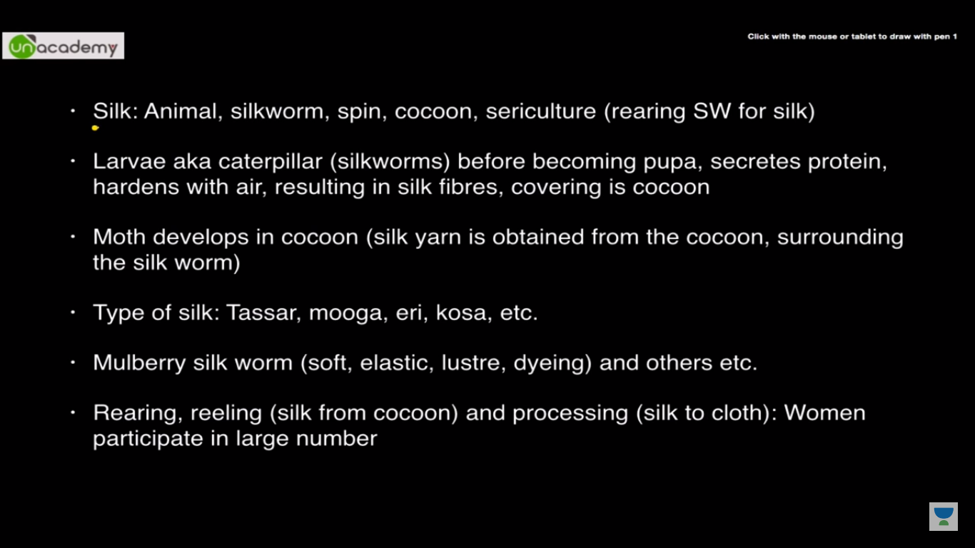

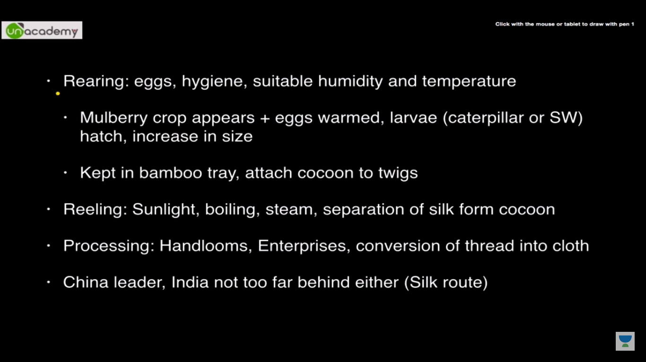

**Chapter 4**

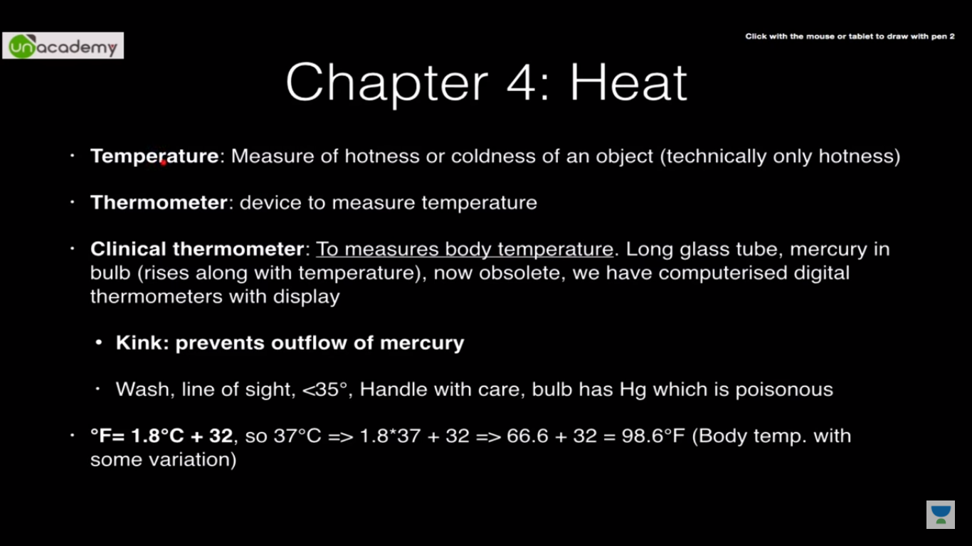

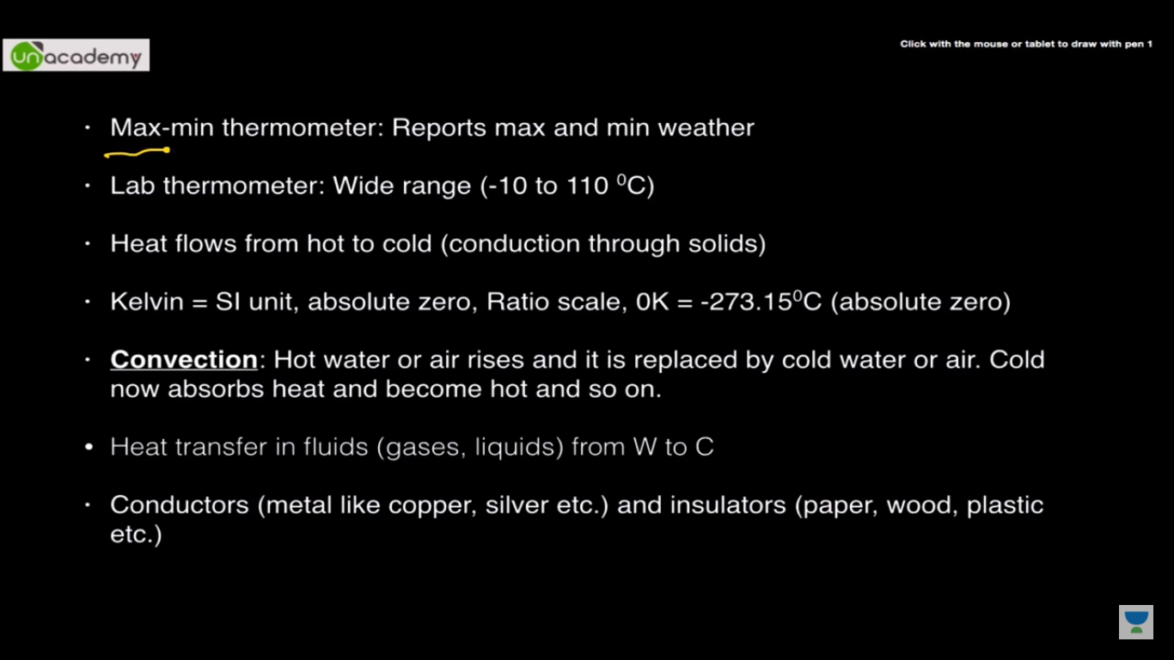

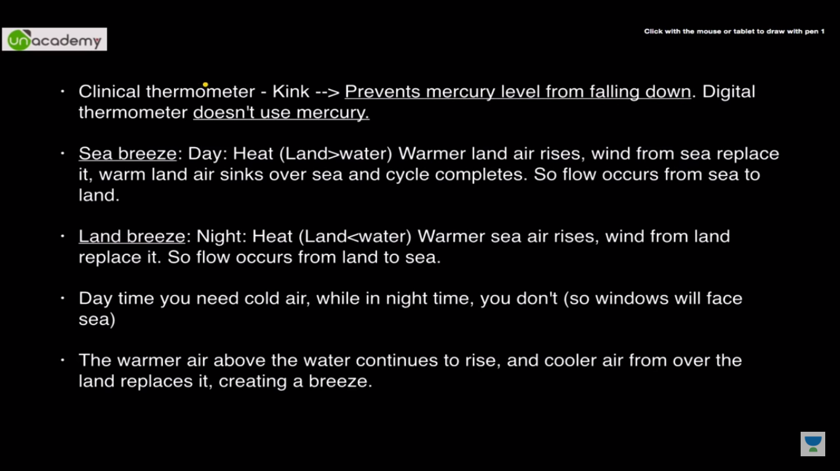

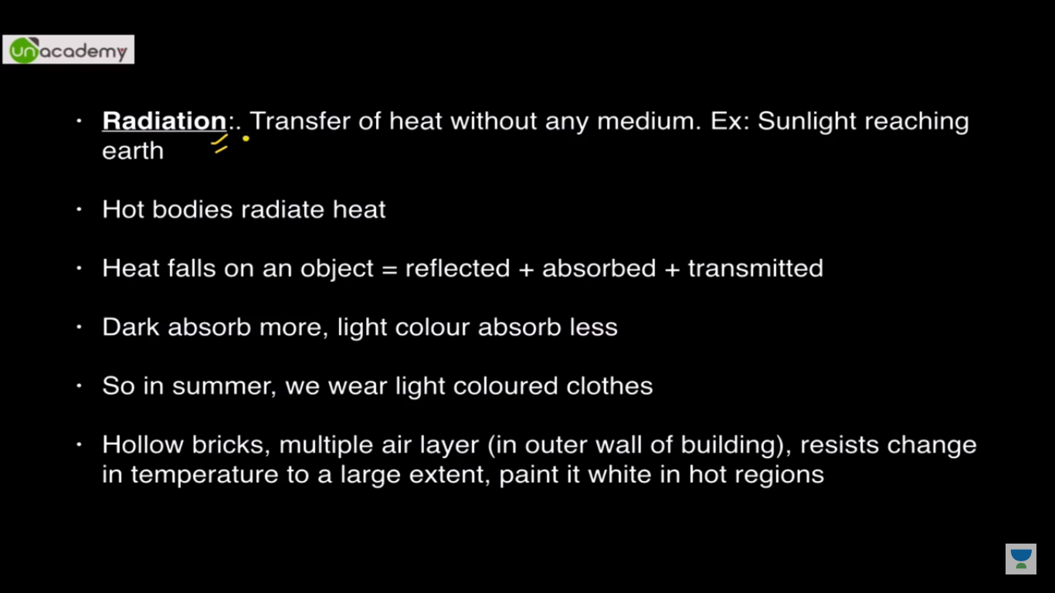

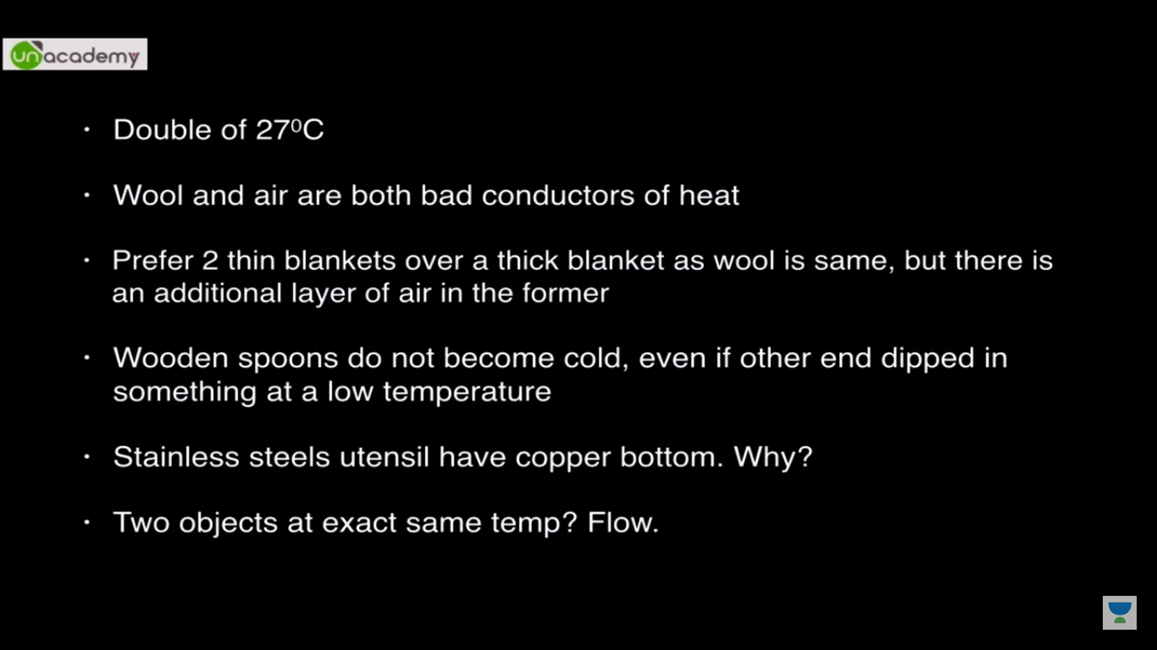

Dynamic equilibrium: Change of heat in same temp

**Chapter 5**

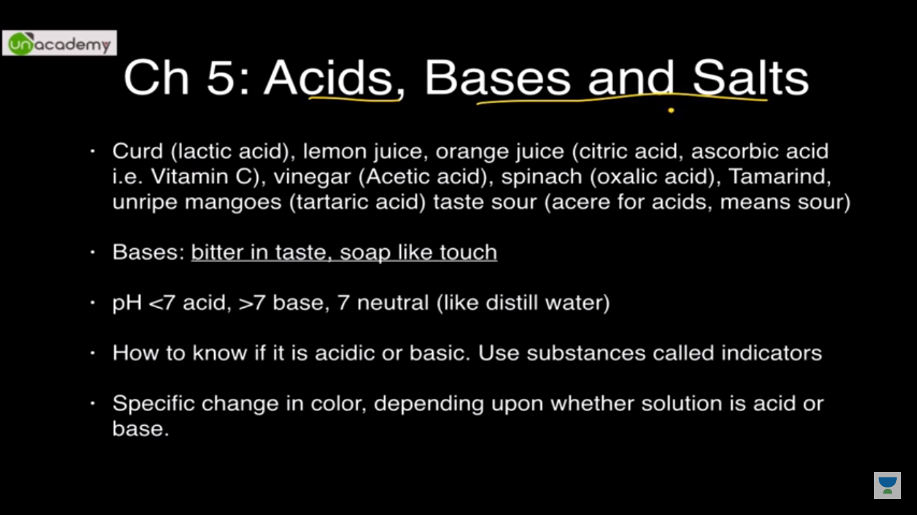

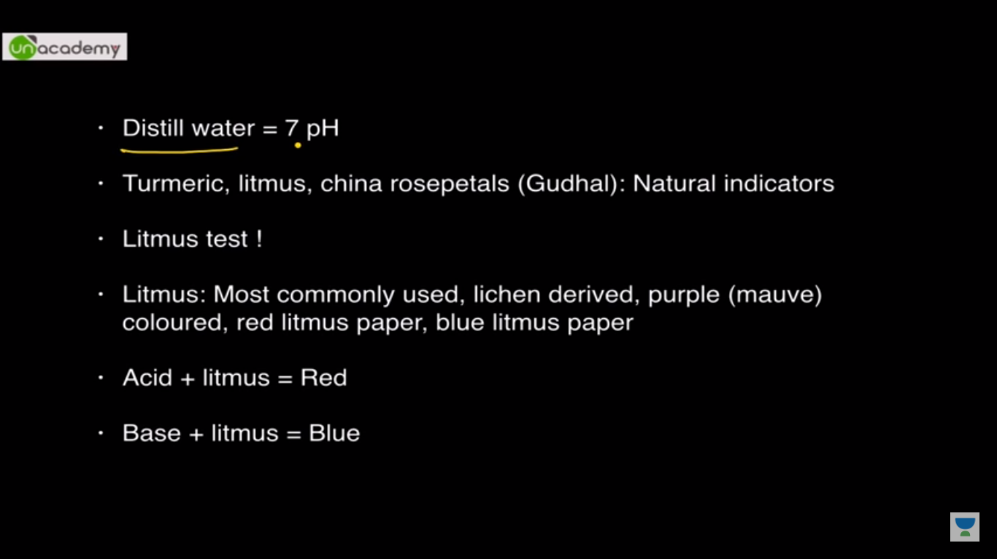

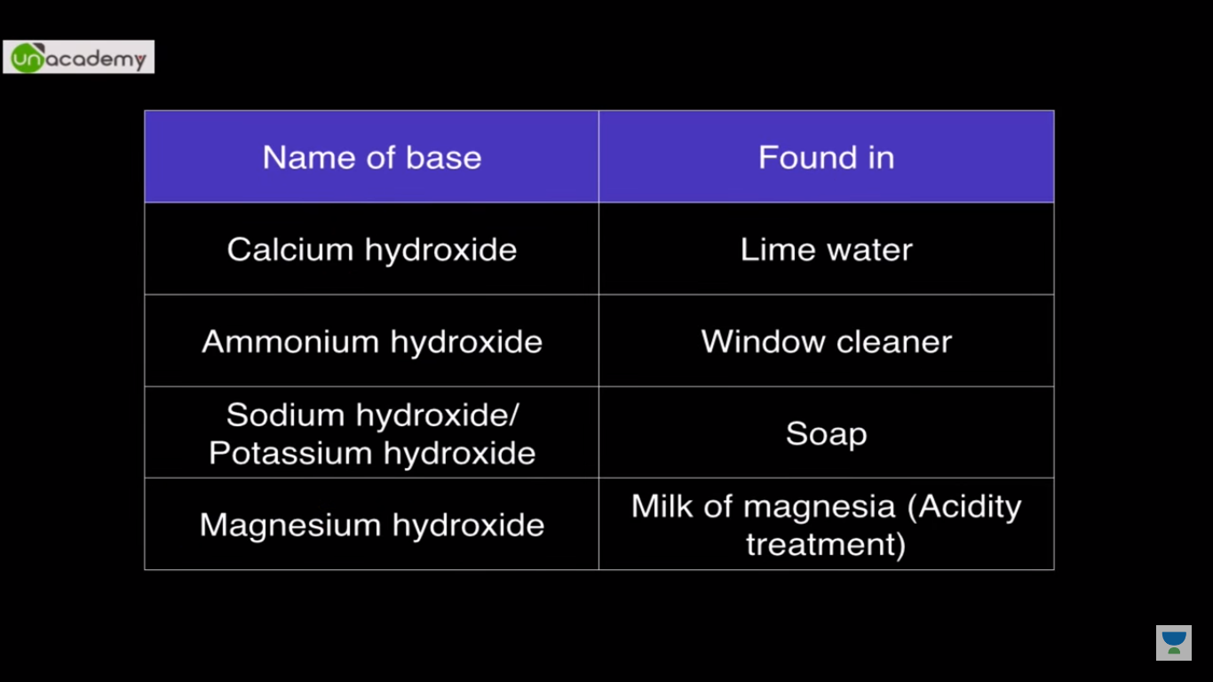

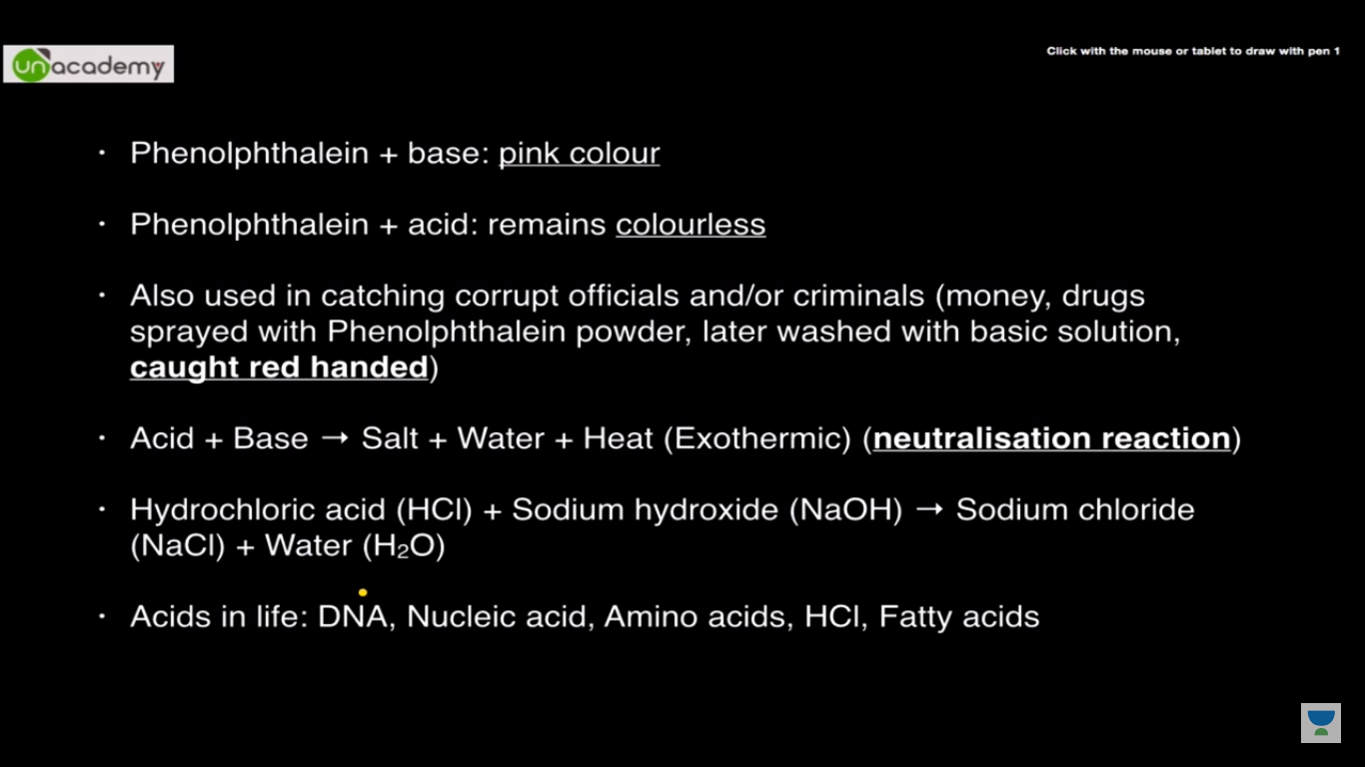

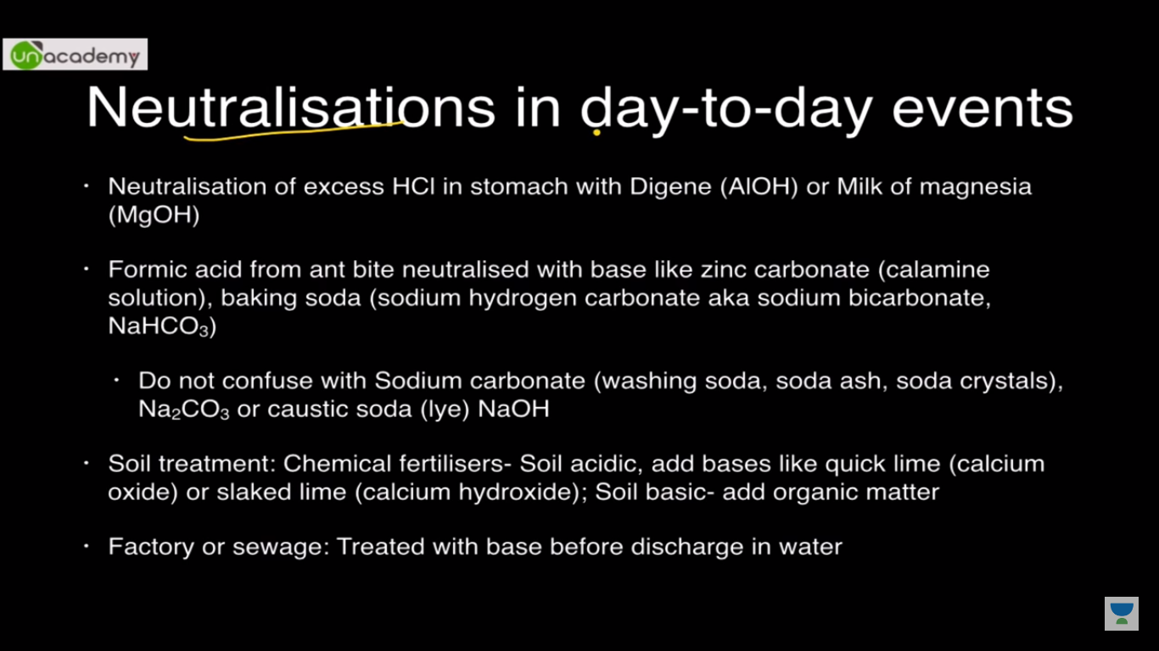

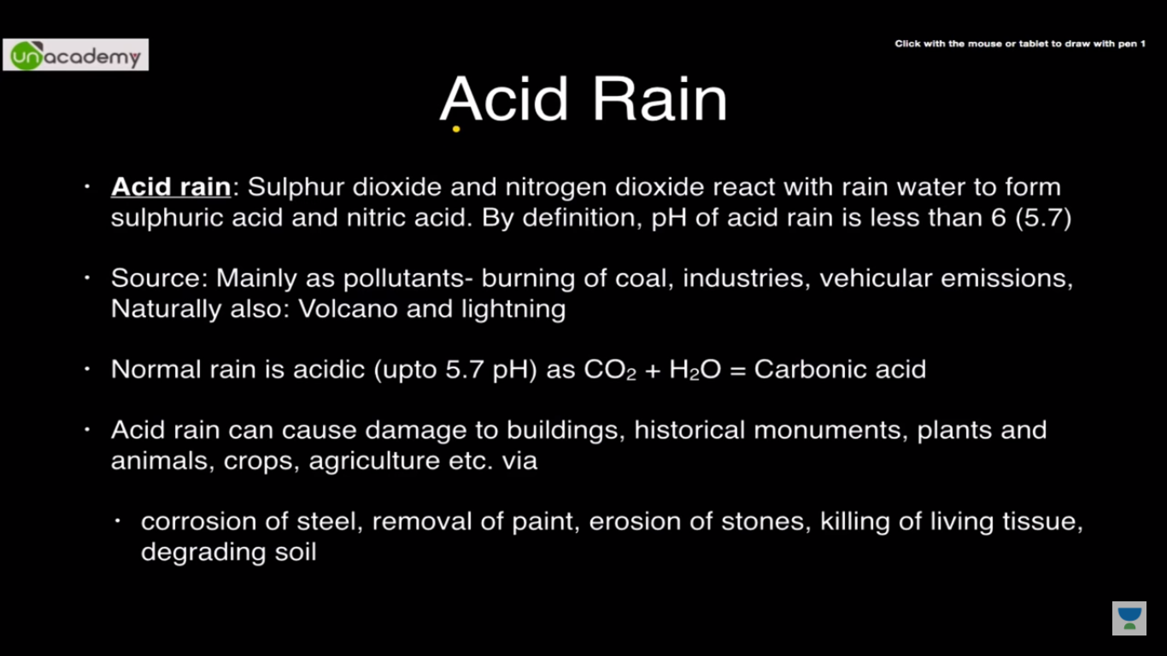

**Chapter 6**

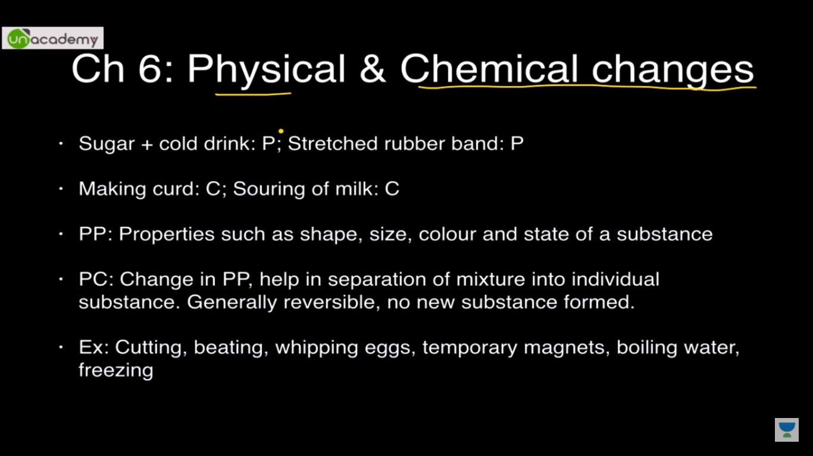

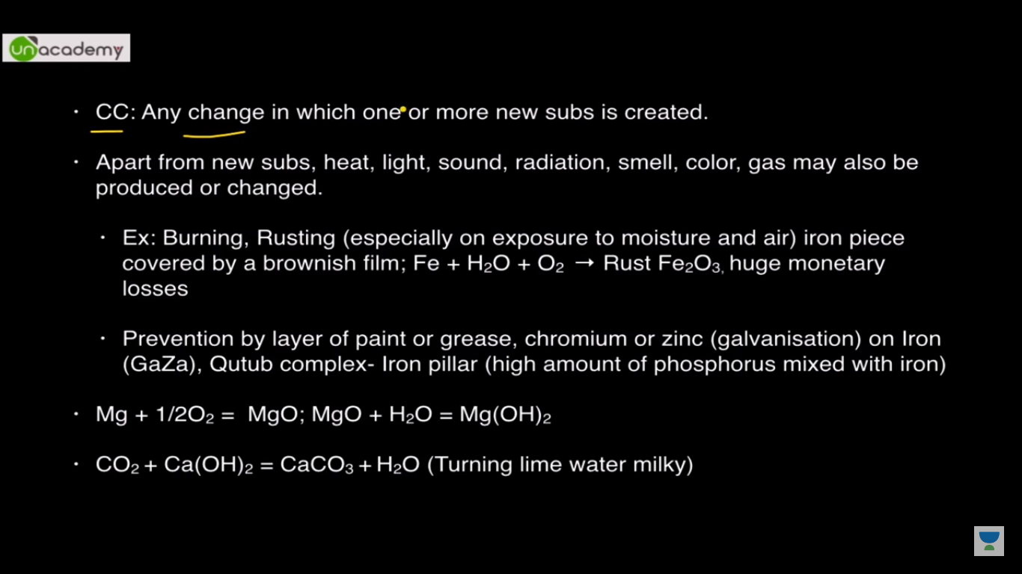

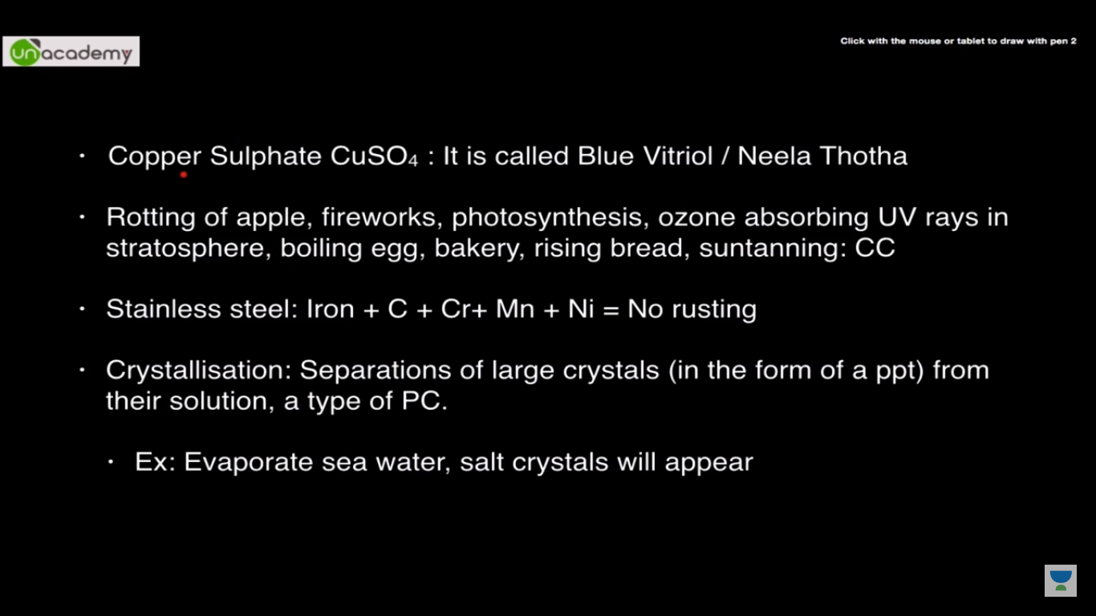

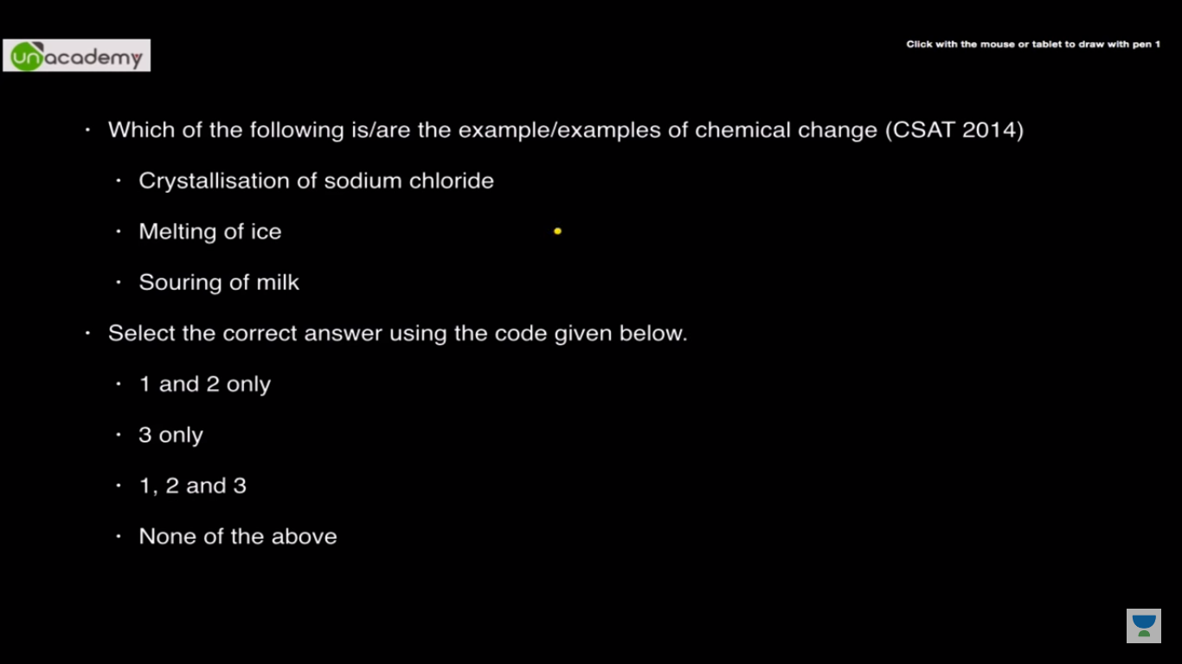

3 only

**Chapter 7:**

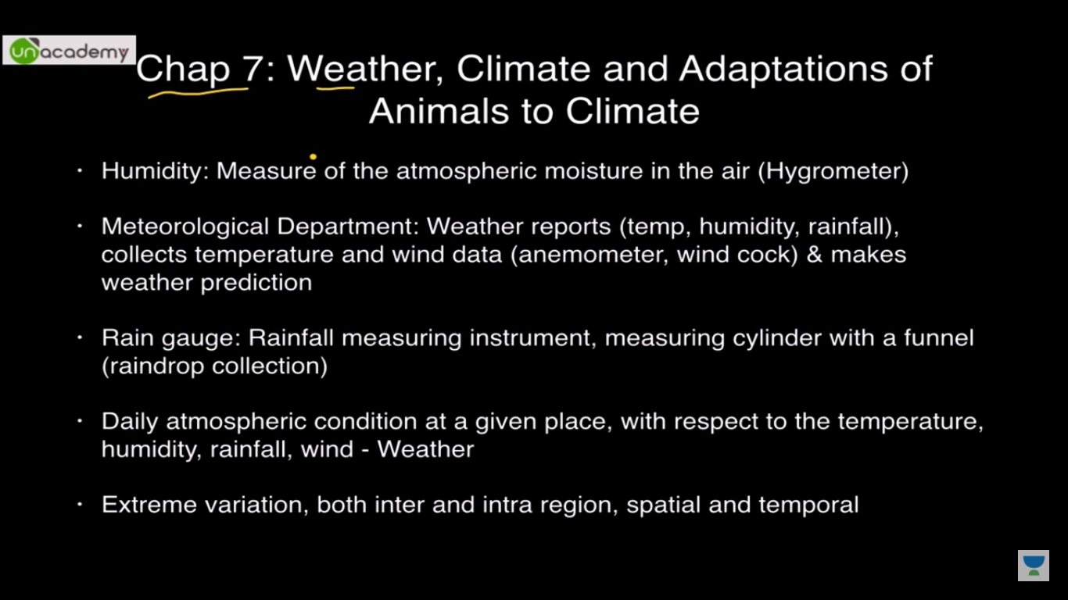

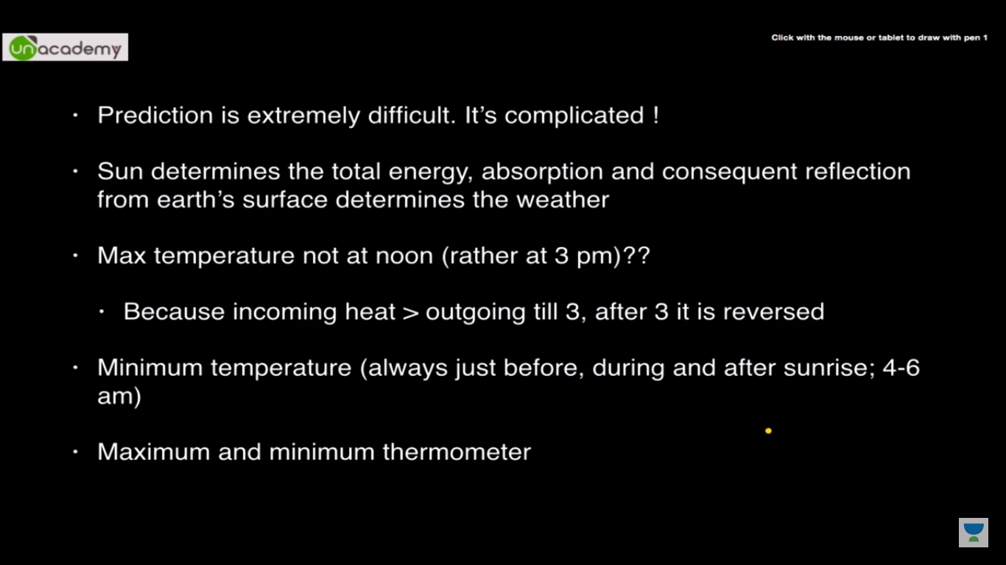

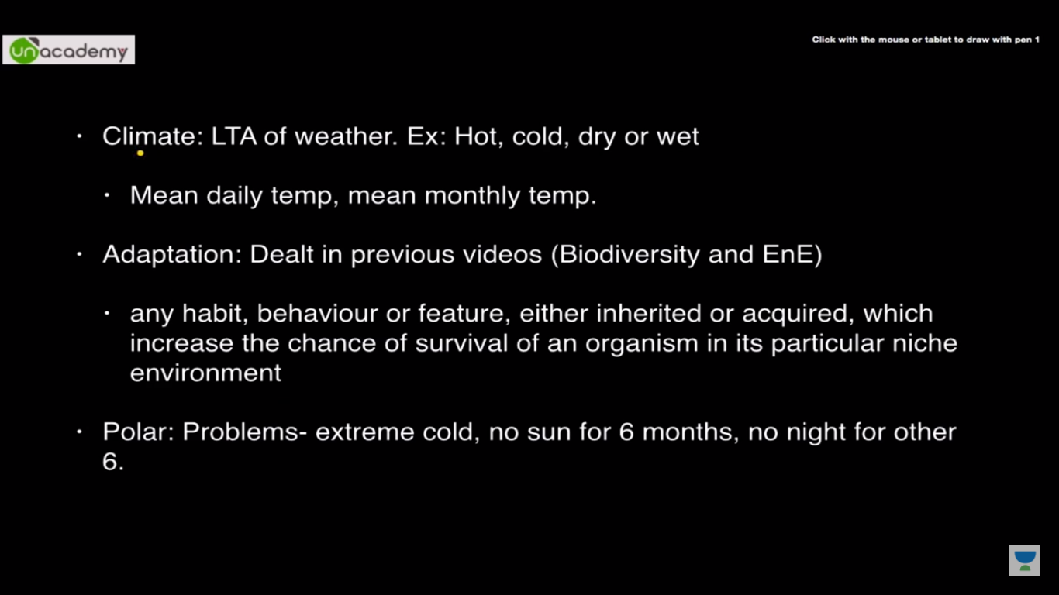

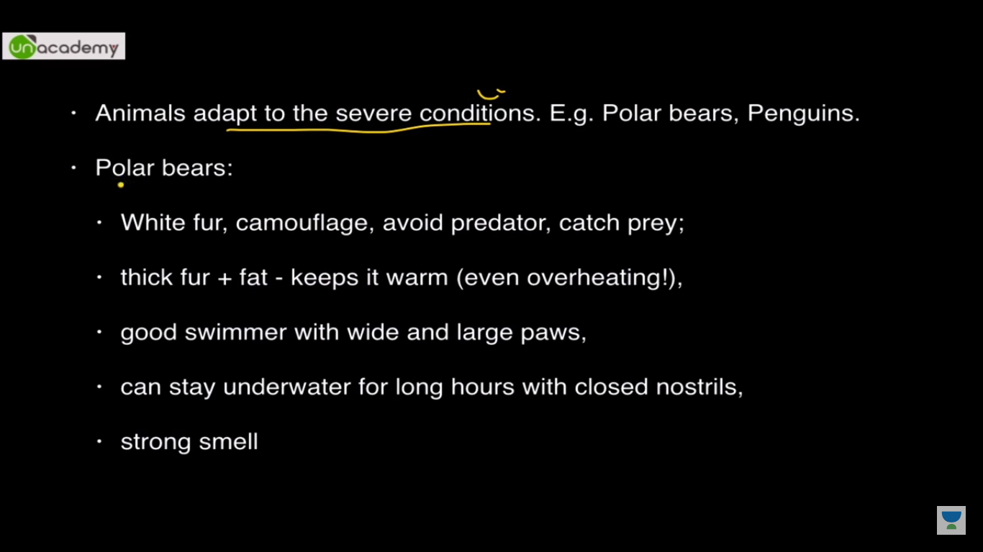

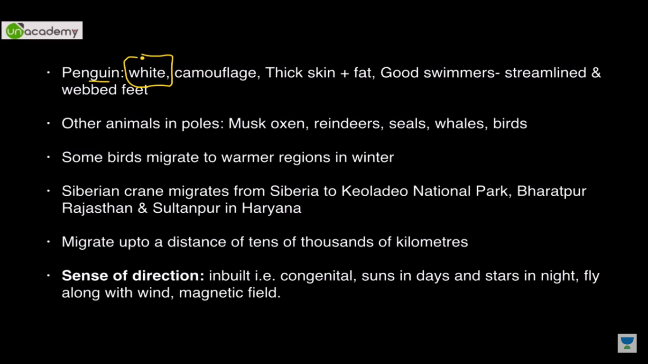

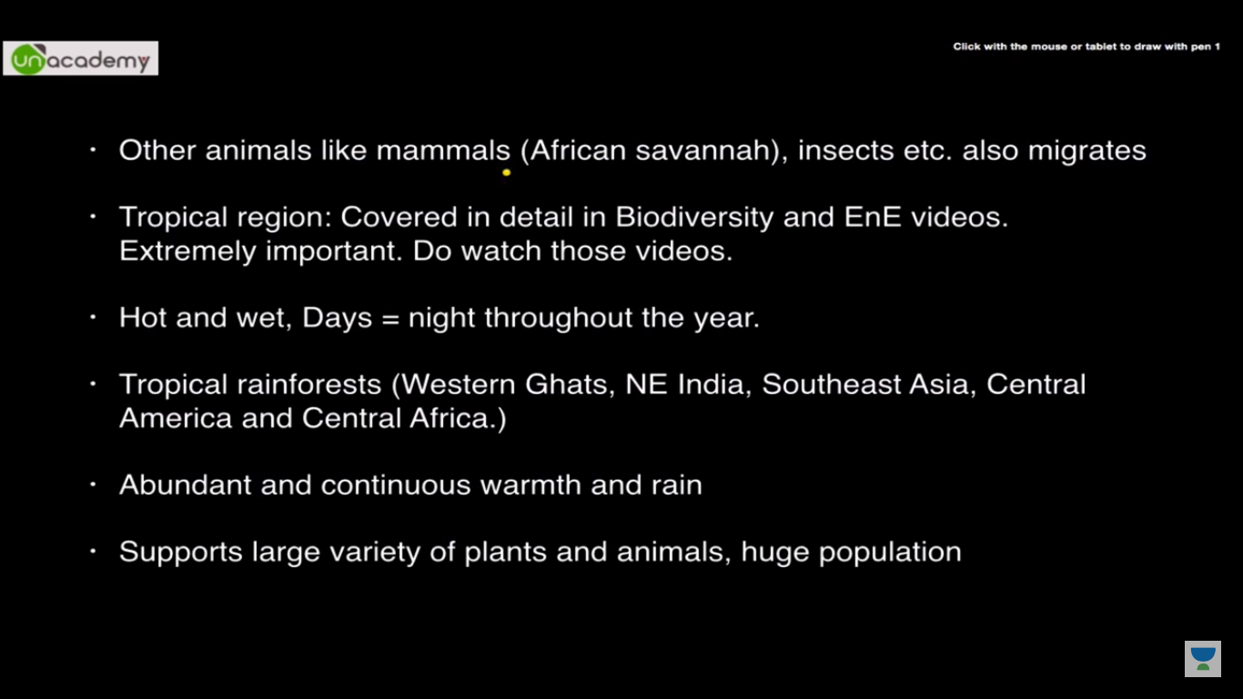

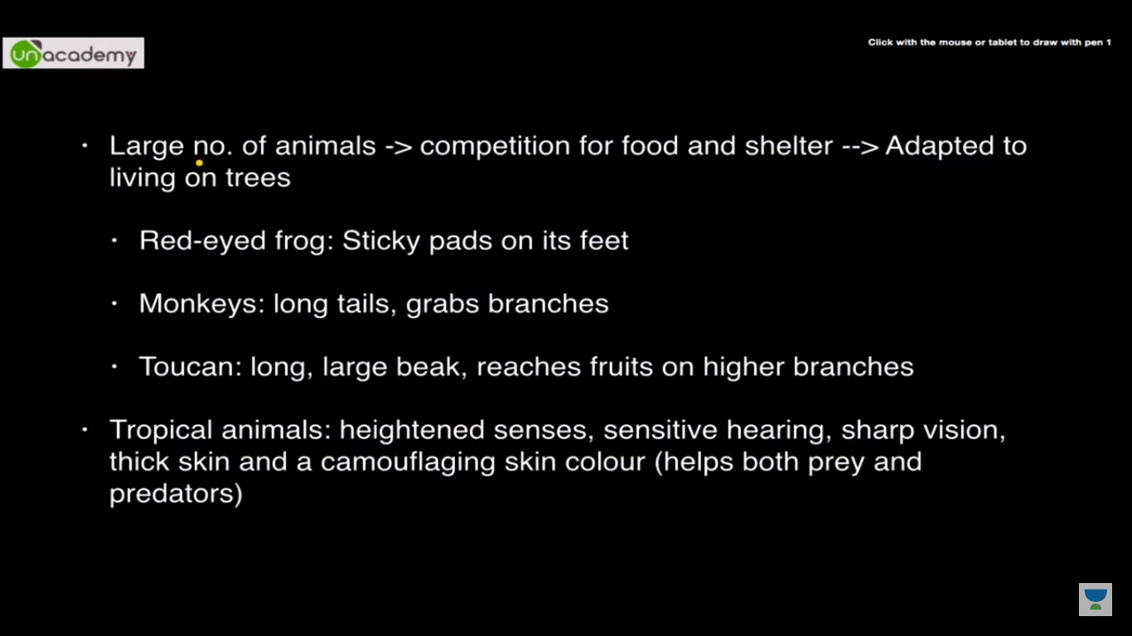

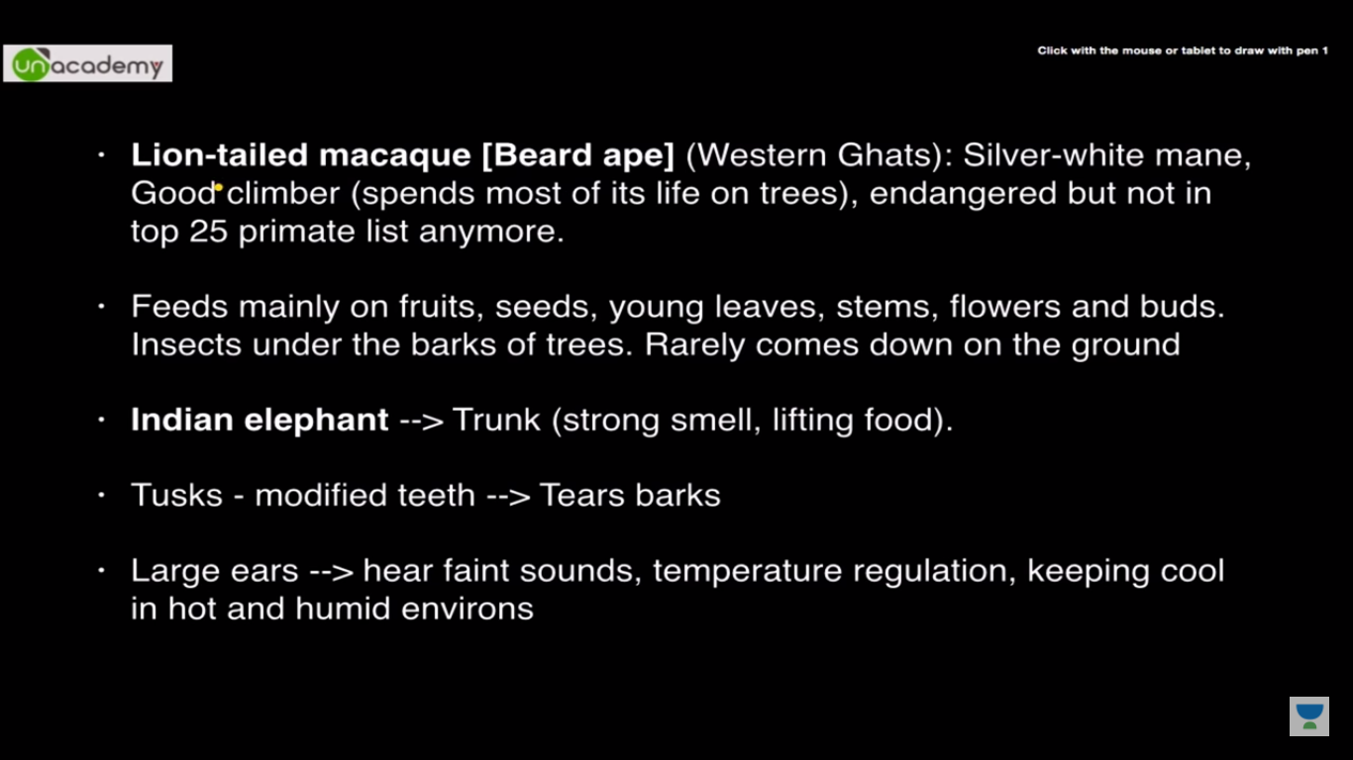

**Chapter 8**

* **Air exerts pressure**
* **High speed winds are accompanied by reduced air pressure**
* **Air moves from the region where the air pressure is high to the region where the pressure is low.**
* **Air expands on heating. The warm air is, therefore, lighter than the cold air.**
* **Wind currents are generated due to uneven heating on the earth.**

1. **Uneven heating between the equator and the poles**



1. **Uneven heating of land and water**

The monsoon winds carry water and it rains.

* **Thunderstorms and cyclones**

rising temperatures produce strong upward rising winds. These winds carry water droplets upwards, where they freeze, and fall down again. The swift movement of the falling water droplets along with the rising air create lightning and sound.

**Cyclone:**

Water takes up heat from the atmosphere to change into vapour. When water vapour changes back to liquid form as raindrops, this heat is released to the atmosphere. The heat released to the atmosphere warms the air around. The air tends to rise and causes a drop in pressure. More air rushes to the centre of the storm. This cycle is repeated. The chain of events ends with the formation of a very low-pressure system with very high-speed winds revolving around it. It is this weather condition that we call a **cyclone.**



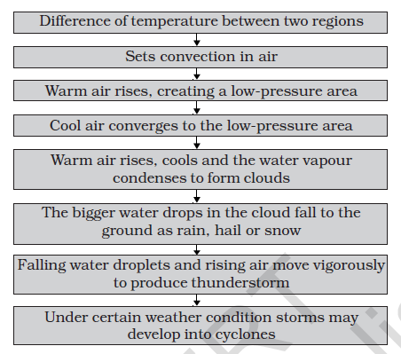

**Chapter 9**

**Soil**

* Polythene bags and plastics pollute the soil. They also kill the organisms living in the soil. That is why there is a demand to ban the polythene bags and plastics.
* The rotting dead matter in the soil is called **humus**.
* You probably know that the soil is formed by the breaking down of rocks by the action of wind, water and climate. This process is called **weathering**
* A vertical section through different layers of the soil is called the **soil profile**. Each layer differs in feel (texture), colour, depth and chemical composition. These layers are referred to as **horizons**



* soil fertile and provides nutrients to growing plants. This layer is generally soft, porous and can retain more water. It is called the **topsoil** or the **A-horizon**.
* The next layer has a lesser amount of humus but more of minerals. This

layer is generally harder and more compact and is called the **B-horizon** or the middle layer.

* The third layer is the **C-horizon**, which is made up of small lumps of rocks with cracks and crevices.
* Below this layer is the **bedrock**, which is hard and difficult to dig with a spade.

**SOIL TYPES:**

The mixture of rock particles and humus is called the soil.

If soil contains greater proportion of big particles it is called **sandy soil**.

If the proportion of fine particles is relatively higher, then it is called

**clayey soil**.

If the amount of large and fine particles is about the same, then the soil is called **loamy**.

Silt occurs as a deposit in river beds.

**PROPERTIES OF SOIL:**

Percolation rate of water in soil

percolation rate (mL/min) =amount of water (mL)/percolation time (min)

* On a hot summer day, the vapour coming out of the soil reflect the sunlight and the air above the soil seems to shimmer
* percentage of water absorbed=((U_V)/50)100
* Clayey and loamy soils are both suitable for growing cereals like wheat, and gram.
* For lentils *(masoor)* and other pulses, loamy soils, which drain water easily, are required.
* For cotton, sandy loam or loam, which drain water easily and can hold plenty of air, are more suitable.
* **Soil Erosion**-The removal of land surface by water, wind or ice is known as erosion. Plant roots firmly bind the soil. In the absence of plants, soil becomes loose. So it can be moved by wind and flowing water.

**Chapter 10**

**Respiration in organism**

* During breathing, we breathe in air. Air contains oxygen. We breathe out air which is rich in carbon dioxide.
* The air we breathe in is transported to all parts of the body and ultimately to each cell. In the cells, oxygen in the air helps in the breakdown of food. The process of breakdown of food in the cell with the release of energy is called **cellular respiration**. Cellular respiration takes place in the **cells of all organisms**.
* When breakdown of glucose occurs with the use of oxygen it is called **aerobic respiration**.
* Food can also be broken down, without using oxygen. This is called **anaerobic respiration**.
* yeast are anaerobes

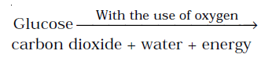

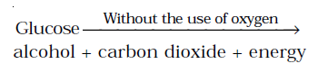

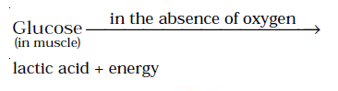

* Accumulation of lactic acid causes muscle cramps. The taking in of air rich in oxygen into the body is called **inhalation** and giving out of air rich in carbon dioxide is known as **exhalation**.
* On an average, an adult human being at rest breathes in and out 15ñ18 times in a minute.



Ribs

Lungs

Trachea

Pharynx

Diaphragam

Oral cavity

Nasal Passage

* When we inhale air, it passes through our nostrils into the **nasal cavity**. From the nasal cavity, the air reaches our **lungs** through the windpipe. Lungs are present in the **chest cavity** (Fig. 10.4). This cavity is surrounded by ribs on the sides. A large, muscular sheet called **diaphragm** forms the floor of the chest cavity. Breathing involves the movement of the diaphragm and the rib cage.

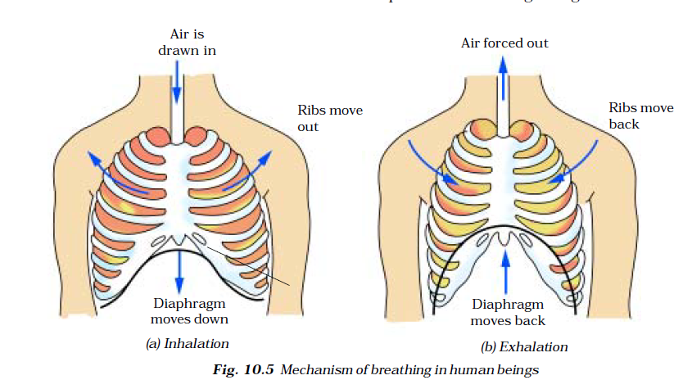

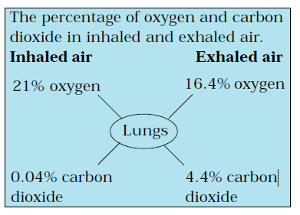

* ***Cockroach:*** A cockroach has small openings on the sides of its body. These openings are called **spiracles**
* Insects have a network of air tubes called **tracheae** for gas exchange
* Oxygen rich air rushes through spiracles into the tracheal tubes, diffuses into the body tissue, and reaches every cell of the body.
* ***Earthworm:*** skin of an earthworm feels moist and slimy on touching. Gases can easily pass through them.
* Though frogs have a pair of lungs like human beings, they can also breathe through their skin, which is moist and slippery.
* **Plants** take oxygen from the air and give out carbon dioxide
* In plants each part can independently take in oxygen from the air and give out carbon dioxide